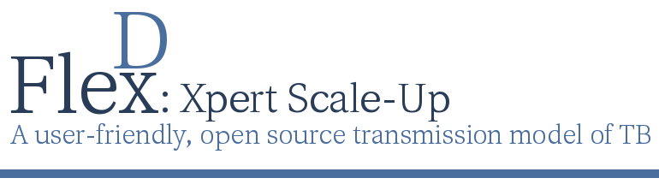

The Flexible Diagnostics TB Model

*A flexible, simple, transmission modeling tool for TB diagnostics*

**FlexDx TB Model User’s Manual**

*Empowering decision makers to generate evidence for implementing TB diagnostics under local conditions*

**Developed by FlexDx Team with support from:**

National Institutes of Health

**FlexDx Team**

**Johns Hopkins Bloomberg School of Public Health,**

**TB Modeling and Translational Epidemiology Group**

David Dowdy

Liza Bronner Murrison

Jeff Pennington

**University of Sheffield, School of Health and Related Research**

Pete Dodd

**Website Citation**

FlexDx: Xpert Scale-Up, A user-friendly open source transmission model of TB [Internet]. Baltimore, MD, USA: Johns Hopkins Bloomberg School of Public Health; 2014 [cited 2014 Sep 22]. Available from: https://flexdx2.modeltb.org.

**Corresponding Manuscript**

Dowdy DW, Andrews JR, Dodd PJ, Gilman RH. A user-friendly, open-source tool to project impact and cost of diagnostic tests for tuberculosis. eLife Sciences [Internet] 2014 [cited 2014 Sep 22];e02565. Available from: http://elifesciences.org/content/early/2014/06/04/eLife.02565

Manual Last Updated: 2014

Table of Contents

Part I: FlexDx Introduction 5

1.1 What is the FlexDx TB Model? 5

1.2 TB diagnostic testing strategies 5

1.3 FlexDx model parameter inputs 6

1.4 Uses of the FlexDx TB Model 6

1.5 Making population projections with FlexDx 7

1.6 Limitations of the FlexDx TB Model 7

1.7 More information and Software support 8

Part II: Using the FlexDx TB Model 10

2.1 Getting started - Steps in making population projections using FlexDx 11

2.2 Using the FlexDx model parameter input options 12

2.2.3 Description of Epidemiological Scenario parameters 14

2.2.4 Description of Costs parameters 14

2.3 Description of TB diagnostic testing strategy options 15

2.4 Running FlexDx for a specified TB diagnostic testing strategy 17

2.4.1 Selecting a Single Strategy 17

2.4.2 Selecting a All Strategies 18

Part III: FlexDx TB Model Results 20

3.1 Output when running with Country Selection for Pre-set Values 21

3.1.1 Interactive Incidence/Cost Tab 22

3.1.2 Interactive MDR/Cost Tab 24

3.1.3 Summary Data Tab 26

3.2 Output when running with User Input Values for a Single Strategy 27

3.3 Output when running with User Input Values for All Strategies 29

3.3.1 Nine Single Strategy Tabs 30

3.3.2 Interactive Incidence/Cost Tab 32

3.3.3 Interactive MDR/Cost Tab 34

3.3.3 Summary Data 36

3.4 Changing the reference group 37

3.5 Extracting results and data 37

3.6 Model validation 38

Part IV: Using FlexDx Results: Case Studies 39

4.1 Case study from India with Country Pre-set Values 39

4.1 Case study from Cape Town, South Africa with User Input Values 43

Part V: FlexDx TB Homebrew Introduction 52

5.1 What is FlexDx Homebrew? 52

5.2 Steps in making a homebrew diagnostic algorithm 52

5.3 Before you get started 52

5.4 Diagnostic test descriptions 52

5.5 User defined tests 52

Description of tool 52

How to define a test 52

5.6 Diagnosis section settings 52

Patient types 52

1st test 52

2nd test 52

Defaults 52

5.7 Diagnostic result section settings 52

5.8 Diagnostic results 52

5.9 Treatment 52

5.10 Options for DST based testing 52

5.11 Sens/Spec (%) 52

Part VI: FlexDx TB Homebrew Results 52

Part VII: Methodology 52

7.1 FlexDx Model 52

7.2 Homebrew Model 52

7.3 Uncertainty analysis 52

Glossary of Terms 52

Acronyms and abbreviations 53

References 54

# Part I: FlexDx Introduction

## 1.1 What is the FlexDx TB Model?

The Flexible Diagnostics (FlexDx) TB Model is a flexible, simple, transmission modeling tool designed by a team including the TB Modeling and Translational Epidemiology Group at the Johns Hopkins Bloomberg School of Public Health and the University of Sheffield. The FlexDx TB Model allows users without modeling expertise to generate evidence to aid decision-making related to implementation of tuberculosis (TB) diagnostics under locally defined conditions.

Using a simple web-based interface, FlexDx incorporates local estimates of TB incidence, MDR-TB, HIV, and costs into a combined decision analysis-transmission framework. The dynamic model then generates five-year projections of the epidemiological impact and cost-effectiveness of nine diagnostic strategies in reducing TB transmission and mortality. The transmission model, as well as the model assumptions and structure, is described in detail in a manuscript by Dowdy et al. available online from eLife Sciences 2014. This manuscript was published on an older version of the FlexDx TB Model, but the methodology is largely similar to the current version which includes interventions related to Xpert that were not originally incorporated.

## 1.2 TB diagnostic testing strategies

Currently, the FlexDx TB Model includes 9 diagnostic strategies for user selection. The user-selected strategies are evaluated in the context of the FlexDx TB transmission model framework to generate five-year projections of the epidemiological impact and cost-effectiveness. The currently available FlexDx TB diagnostic strategies are focused on the scale-up of the Xpert MTB/RIF assay (Cepheid, Inc., Sunnyvale, CA, USA) with options including:

1. Baseline (Sputum smear microscopy for each diagnostic attempt)
2. Xpert for smear positive only
3. Xpert for HIV positive only
4. Xpert for previously treated only
5. Xpert for smear negative or previously treated only
6. Xpert for all HIV+ or previously treated only
7. Xpert for smear negative only
8. Xpert for all
9. Xpert for all, same-day

The FlexDx TB Model will return estimates of five-year projections of the epidemiological impact and cost-effectiveness of the user-selected diagnostic strategy(s). Additional details are provided in Section 2.3.

## 1.3 FlexDx model parameter inputs

When operating the FlexDx TB Model, users have two options for defining their local epidemic situation. For ease of use, we offer the option to run the FlexDx TB Model using (1) country pre-calculated values from WHO for your country of interest. Additionally, for added flexibility and customization, users may run the model by (2) entering their own values for key epidemiological parameters and local unit costs of TB diagnosis and treatment. Additional details are provided in Section 2.4.

## 1.4 Uses of the FlexDx TB Model

Given the number of new diagnostic strategies for active TB now recommended by the WHO, TB program decision-makers must repeatedly determine how to invest in scaling up novel diagnostic tests. FlexDx can be applied to programmatic planning and management areas to provide important guidance to decision-makers working in the areas of:

* Tuberculosis (drug-susceptible)
* Drug-resistant and Multidrug-resistant TB
* HIV/AIDS
* Operational Research
* Implementation Science

FlexDx can be used at all levels of public health to enable local decision-makers to systematically choose those interventions that are likely to have the greatest impact under local epidemiology and resource constraints to support public health applications such as:

* Policy and Advocacy
* Research and Planning
  + National Strategic Plan Development
  + Budget Forecasting
* Funding Applications
  + Global Fund, Private Donors, Government
* Health Services Prioritization
  + TB Resources
  + Diagnostic Scale-Up

Overall, the FlexDx TB Model serves as a dynamic user-friendly tool that can rapidly provide decision-makers with access to customizable “first-pass” projections of cost and impact from transmission models without the need to construct specific models to represent all possible epidemiological settings.

## 1.5 Making epidemiologic projections with FlexDx

While the FlexDx TB Model cannot precisely replicate an epidemiological situation in any given location, it can be used to apply a standardized methodology across a wide range of settings. This allows users to evaluate various diagnostic strategies in that setting in terms of population-level costs and impact. Epidemiologic projections are usually made at the national level; however, FlexDx enables users to make projections for other geographic areas by entering the corresponding locally relevant values for TB incidence, MDR-TB prevalence, adult HIV prevalence, and TB treatment costs.

By focusing on the population-level epidemiologic projections, FlexDx is able to illustrate important interactions between epidemiological parameters and projected impact. This becomes especially important as a basis for programmatic planning where implementation of different diagnostic strategies on actual population-level costs and impact often differ dramatically across epidemiologic settings. In this way, epidemiologic projections are most useful to serve as the basis for projecting future program and population needs.

When using the FlexDx TB Model to make projections, it is key that users examine the estimated projections carefully to ensure their application in your setting and to ensure that they are epidemiologically realistic. FlexDx is intended to provide access to “first-pass” estimates in a user-friendly format without the need for more detailed and tightly fitted models. However, FlexDx does not eliminate the utility of more precise models incorporating additional setting-specific indicators (e.g., demographic and socioeconomic indicators) that are not included in estimating the FlexDx projections.

## 1.6 Limitations of the FlexDx TB Model

As with any modeling analysis, the FlexDx TB Model and the user generated results from the model have important limitations.

* In order to provide sufficient flexibility and generalizability, FlexDx makes a number of strong assumptions that include a constant population, homogeneous mixing, no change in parameter values over time, and simplistic incorporation of HIV and drug resistance.
* FlexDx focuses on transmission dynamics and thus does not include pediatric TB and extrapulmonary TB; these largely non-infectious disease manifestations remain very important components of the TB epidemic that are not captured here.
* FlexDx was validated against global estimates and other models; though ideally, further validation would be performed over time using field data across a wide variety of settings.
* The ability to input FlexDx parameters is dependent upon the availability of data that may not be available for many sub-national settings.
* FlexDx is linked to WHO estimates to allow users to select their country of interest to populate the TB incidence, MDR-TB prevalence, and adult HIV prevalence parameters using for the specified country. This linkage provides users with potentially applicable baseline estimates for the input parameters in their setting, which they could then vary to perform their own setting-specific sensitivity analysis.
* Similarly, FlexDx provides globally representative uniform cost estimates that are pre-populated to operate the model that can serve as baseline estimates or be used in sensitivity analysis for a given setting.
* FlexDx provides users with the ability to specify TB incidence, MDR-TB prevalence, and adult HIV prevalence, allowing for a number of scenarios can be created (e.g., low TB incidence and very high adult HIV prevalence) that are not epidemiologically realistic.

Thus, while FlexDx can be a very useful tool to provide access to “first-pass” estimates in epidemiological settings (e.g., sub-district level data) that will never be captured by more detailed and closely-calibrated TB transmission models, it does not eliminate the necessity for more detailed models.

## 1.7 More information and Software support

We have a manuscript that was published in eLife Sciences in 2014 that is available online at http://elifesciences.org/content/early/2014/06/04/eLife.02565 that provides additional details about the model. This manuscript was published on an older version of the FlexDx TB Model, but the methodology is largely similar to the current version which includes interventions related to Xpert that were not originally incorporated. Please email Dr. David W. Dowdy (ddowdy1@jhmi.edu) if you have any questions or problems related to using the FlexDx TB Model.

Additionally, as with any modeling analysis, this research has important limitations. We have done our best to benchmark this model against the published literature, but we also make our code freely available at [https://github.com/JJPennington/FlexDx-TB-Web-Django](https://mail.jhsph.edu/owa/redir.aspx?C=6ceb0382797c42ffb24566b465749bdc&URL=https%3a%2f%2fgithub.com%2fJJPennington%2fFlexDx-TB-Web-Django).

For more information or to access the help files for the FlexDx Model, users can click on the ‘About’ and ‘Help’ buttons on the model input page.

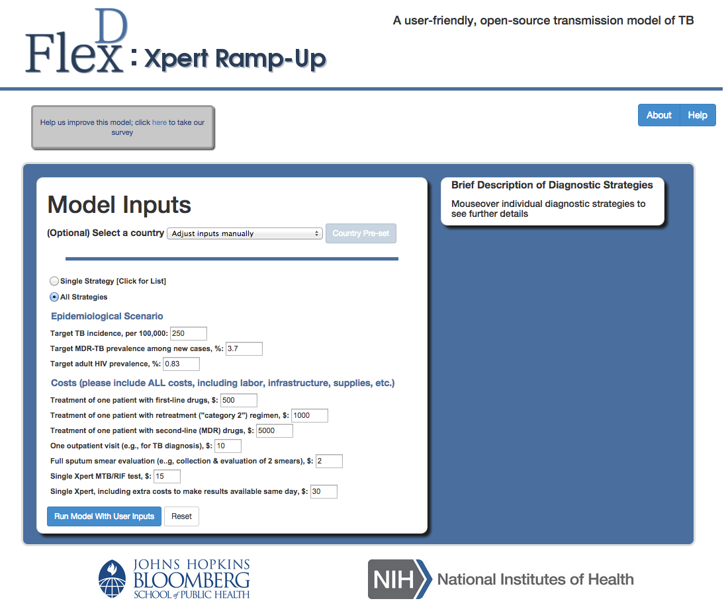

**Click here for Help Files or more information about the model’s creators**

# Part II: Using the FlexDx TB Model

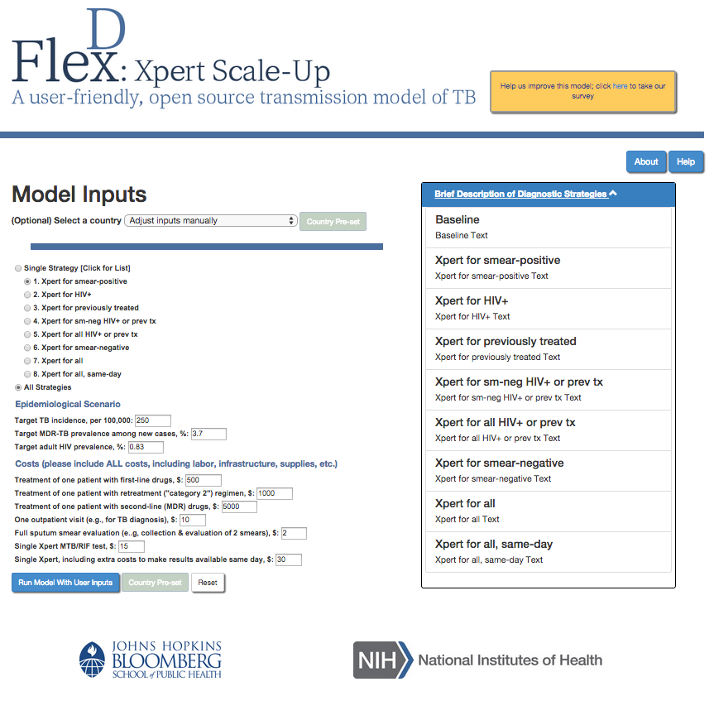

## 

## 2.1 Getting started - Steps in making epidemiologic projections using FlexDx

There are several key steps in making epidemiologic projections that are built into the FlexDx TB Model. You will need to consider your available data and make certain decisions when running the FlexDx TB Model. These include:

1. **Select your geographic area of interest.** While most epidemiologic population projections are made at the national level, they can also be made for other geographic areas such as urban areas, capital cities, provinces, districts, and others using FlexDx to assess the impact of implementing new diagnostic strategies on your geographic area of interest.
2. **Determine the period of the projection.** Epidemiologic projections in FlexDx start at Year 1 for which the current values for the key epidemiological parameters (TB incidence, proportion of new TB cases MDR, and HIV prevalence) and local unit costs of TB diagnosis and treatment are entered. The FlexDx model then incorporates those estimates into a combined decision analysis-transmission framework to generate projections of TB incidence, mortality, and control costs for nine diagnostic strategies in Year 5 of the program. These five year projections can be especially useful for planning activities in the short-term.
3. **Collect and enter data.** When using the FlexDx TB Model, users have the option to enter their data for the key epidemiological parameters (TB incidence, proportion of new TB cases MDR, and HIV prevalence) and local unit costs of TB diagnosis and treatment to make projections. Alternatively, users can run the FlexDx TB Model using pre-calculated values are generated using WHO estimates.
4. **Make assumptions.** Epidemiologic population projections and modeling analyses require assumptions about the future. The FlexDx TB Model makes a number of strong assumptions In order to provide sufficient flexibility and generalizability as a user-friendly tool. The FlexDx TB Model assumes a constant population, homogeneous mixing, no change in parameter values over time, and simplistic incorporation of HIV and drug resistance to allow for customizable and rapid result delivery to its users.
5. **Examine projections.** When making a projection with the FlexDx TB Model, it is key that users examine the projection carefully. FlexDx is intended to provide access to “first-pass” estimates in settings where more detailed and tightly fitted models are not available, but it does not eliminate the necessity for more detailed models. Consideration must be made for additional setting-specific indicators (e.g., demographic and socioeconomic indicators) that are not included in estimating the FlexDx projections.
6. **Make alternative projections.** FlexDx can also be used to generate alternative projections by varying one or more of the key epidemiological parameters or local unit costs. Projections made using the FlexDx TB Model should be examined critically to ensure their application in your setting and to ensure that they are epidemiologically realistic.

## 2.2 Using the FlexDx model parameter input options

When running the FlexDx TB Model, users have two options for defining their local epidemic situation. For ease of use, we offer the option to run the FlexDx TB Model using (1) country pre-calculated values from WHO for your country of interest. Additionally, for added flexibility and customization, users may run the model by (2) entering their own values for key epidemiological parameters and local unit costs of TB diagnosis and treatment.

**2.2.1 Selecting a Country for Pre-Set Values**

The Pre-Set Values are generated using WHO estimates for the countries listed. Selecting a country with pre-calculated values will return pre-calculated model results for all diagnostic strategies, including uncertainty ranges and exploration of key alternative scenarios in which important parameters (empiric treatment, reactivation, pre-diagnostic period) are doubled.

To run the model using the Country Pre-Set Values option, the user must select their country of interest from the drop down menu. This will populate the model input parameters using the pre-set values for the country. After selecting a country, the user can click the “Country Pre-Set” button to run the model. Running the model this way will return projections for all diagnostic strategies.

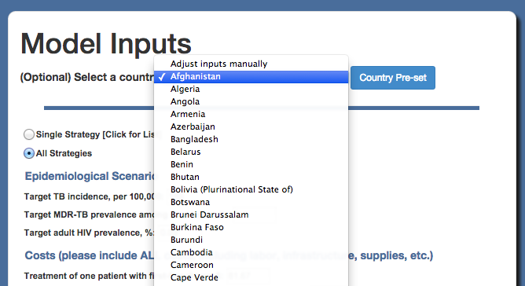

**Select country and then click here**

**2.2.2 Selecting and Entering User Input Values (for All Strategies or a Single Strategy)**

This option allows the user to enter their own values for the baseline parameters and to select all strategies or a single diagnostic strategy from the list to compare with the Baseline (smear) strategy.

Running the model with User Inputs will return projected results for the indicators listed in the Model Output Results in Part 3. However, running the model with User Inputs will not provide uncertainty ranges or alternative scenarios such as those returned when running the model with Country Pre-set Values (as these calculations take too long to be efficiently done in real time).

Users can run the model with User Inputs for a Single (diagnostic) Strategy or for All Strategies. To run the model with User Inputs, the user must select their diagnostic strategy of interest. Next, the user must enter the parameter estimates under the Epidemiological Scenario and Costs sections. Once these data are entered, the user can run the model by clicking the “**Run Model with User Inputs**” button.

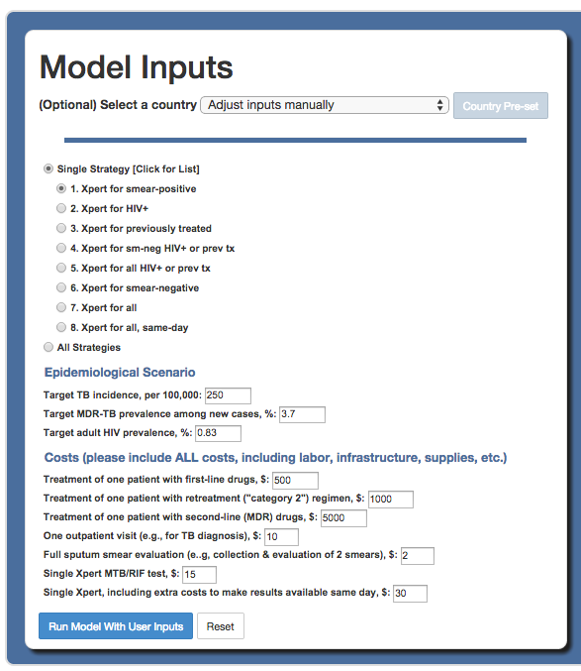

**1. Select Diagnostic Strategy**

**2. Enter Epidemiological**

**Scenario and Costs data**

**Click here to run the model**

### 2.2.3 Description of Epidemiological Scenario parameters

The FlexDx TB Model offers users the option of entering their data to populate the epidemiologic indicators to run the model. This option gives users the flexibility to customize the model and its results to their local setting.

The following epidemiological indicators must be entered to define the Epidemiological Scenario for the FlexDx model to run:



* **Target TB incidence, per 100,000:** This is the current TB incidence rate in the target country or setting of interest.
* **Target MDR-TB prevalence among new cases, %:***(Pre-loaded global value = 3.7%)* This is the current prevalence or percentage of MDR-TB among newly diagnosed cases in the target country or setting of interest.
* **Target adult HIV prevalence, %:***(Pre-loaded global value = 0.8%)* This is the current HIV prevalence among adults >15 years old in the population in the target country or setting of interest.

### 2.2.4 Description of Costs parameters

These costs represent the current cost for each treatment and diagnostic test parameter, including all component costs such as labor, transport, etc. Note that this is not just the “price tag” for an item (for example, the price of drugs), but also includes all additional costs including underlying support staff, transport costs, delivery, etc.



The pre-loaded values represent global estimated values. However, these pre-loaded values are unlikely to reflect the actual costs in any given setting, so users are encouraged to change these costs to reflect their local conditions.

The following cost parameters must be entered in U.S. dollars ($):

* Treatment of one patient with first-line drugs, $
* Treatment of one patient with retreatment ("category 2") regimen, $
* Treatment of one patient with second-line (MDR) drugs, $
* One outpatient visit (e.g., for TB diagnosis), $
* Full sputum smear evaluation (e.g, collection & evaluation of 2 smears), $
* Single Xpert MTB/RIF test, $
* Single Xpert, including extra costs to make results available same day, $

## 2.3 Description of TB diagnostic testing strategy options

The currently available FlexDx TB diagnostic strategies are listed below. These implementation strategies focus on the scale-up of the Xpert MTB/RIF assay for TB diagnosis. The diagnostic strategy options vary by changing the use of Xpert MTB/RIF within the TB diagnostic algorithm.

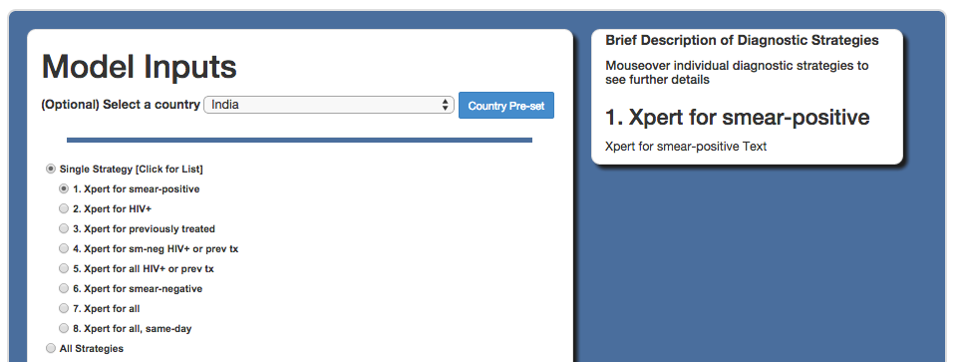

**Diagnostic Strategy options**

For each option listed below, the Xpert MTB/RIF assay is assumed to be deployed at the district level, such that results cannot generally be provided during the same clinical encounter (except in the case of the same-day scenario). The projected results assume immediate implementation of the diagnostic strategy at the beginning of a given year (“Year 1”):

1. **Baseline (Smear):** Sputum smear microscopy for each diagnostic attempt, with liquid-media TB culture only to evaluate smear-positive cases with a history of previous TB treatment for drug resistance.
2. **Xpert for smear positive only:** Sputum smear for all patients, plusXpert MTB/RIF for smear-positive patients only (i.e., for rapid DST), with a positive test for rifampin resistance triggering treatment for MDR-TB.
3. **Xpert for HIV positive only:** Xpert MTB/RIF for HIV-infected patients only, with a positive test for rifampin resistance triggering treatment for MDR-TB. This strategy is conceived as a “best-case” scenario for HIV targeted TB testing: if individuals unaware of their HIV status are not tested with Xpert, this strategy will overestimate effectiveness, and if those unaware of their status are tested, it will underestimate costs.
4. **Xpert for previously treated only:** Xpert MTB/RIF used to diagnose TB in any previously treated individual with symptoms regardless of smear status, with a positive test for rifampin resistance triggering treatment for MDR-TB.
5. **Xpert for smear negative or previously treated only:** Sputum smear for all new patients, plusXpert MTB/RIF used to diagnose TB in any smear-negative patient or previously treated individual, with a positive test for rifampin resistance triggering treatment for MDR-TB.
6. **Xpert for all HIV+ or previously treated only:** Xpert MTB/RIF for HIV-infected patients and previously treated individuals with symptoms regardless of smear status, with a positive test for rifampin resistance triggering treatment for MDR-TB.
7. **Xpert for smear negative only:** Sputum smear for all new patients, plusXpert MTB/RIF used to diagnose TB in any smear-negative patients with persistent symptoms, with a positive test for rifampin resistance triggering treatment for MDR-TB.
8. **Xpert for all:** Xpert MTB/RIF for all patients with TB symptoms.
9. **Same-Day Xpert:** Xpert MTB/RIF for all patients with TB symptoms, including the ability to provide results to patients in the same clinical encounter (e.g., peripheral deployment). Note that the per-test cost of same-day Xpert should be higher.

The FlexDx TB Model will return estimates of five-year projections of the epidemiological impact and cost-effectiveness of the user-selected diagnostic strategy(s). These estimates represent the projected results of implementation of the diagnostic strategy(s) for the first year of implementation, “Year 1,” and for the fifth year after implementation of the strategy(s), “Year 5.”

## 2.4 Running FlexDx for a specified TB diagnostic testing strategy

### 

After deciding whether to use Country Pre-set Values or User Inputs to populate the necessary model parameters, the user must decide on their diagnostic strategy of interest. Users can choose to assess the impact of a Single (diagnostic testing) Strategy or All Strategies.

If the user selects a Single Strategy, FlexDx will run the model and return projections for the impact and cost-effectiveness of the single user-selected strategy. If the user selects All Strategies, FlexDx will run the model to assess the impact of each of the diagnostic testing strategies offered.

### 

### 2.4.1 Selecting a Single Strategy

Users can assess the impact of scaling-up one of the eight diagnostic testing strategies by selecting their Single Strategy of interest.

The eight single testing strategies are listed when the user clicks the “Single Strategy” button. After clicking on “Single Strategy,” users can click on the diagnostic test options to select their strategy of interest. Users can view a description of each strategy displayed to the right when they scroll over each option.

**1. Click here for a Single Strategy**

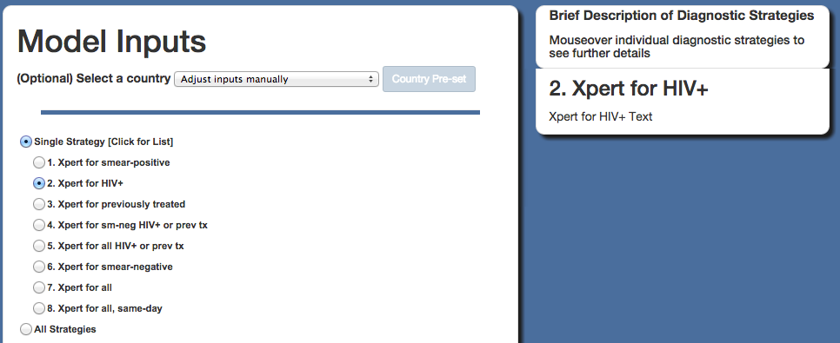

**2. Click to select single strategy of interest**

To return detailed model output results for a Single Strategy, users must run FlexDx with User Input Values for the model parameters.

If the user does not have these data available, the user can first select their country of interest to load the Country Pre-set Values for the model parameters. The user will then click to select their Single (diagnostic) Strategy. To run the model, the user then clicks “Run Model with User Input Values“ to return detailed results for the Single Strategy.

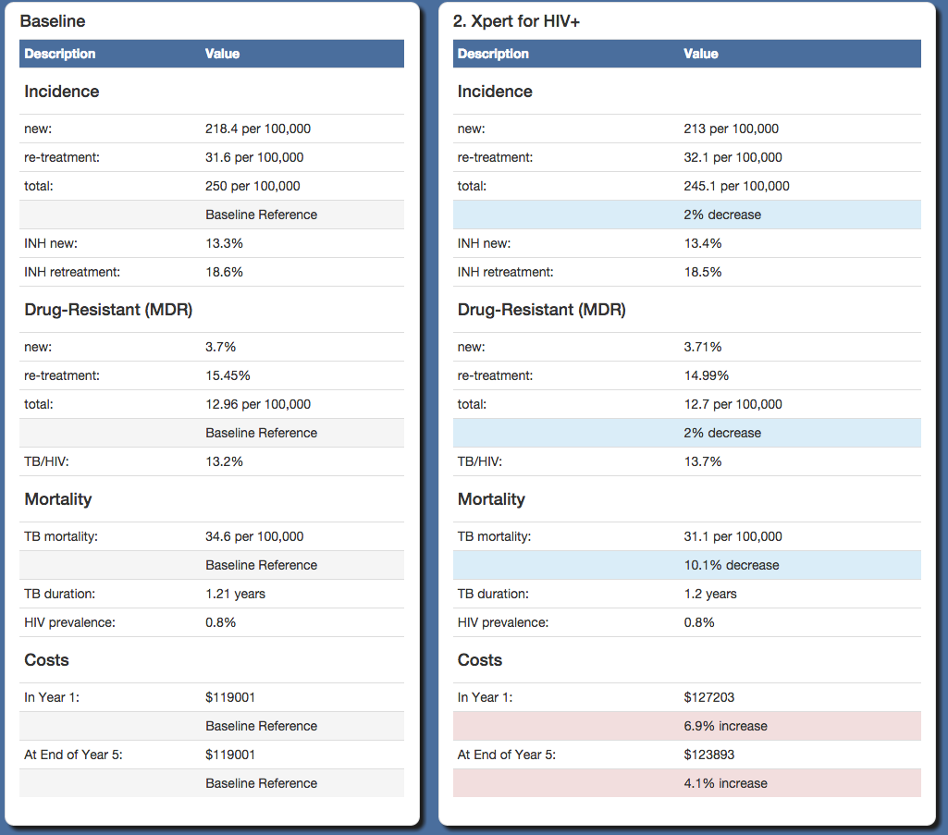

***Detailed model output for a Single Strategy with User Input Values***

### 2.4.2 Selecting a All Strategies

Alternatively, users can also assess the *independent impact* of each one of the eight diagnostic testing strategies in one run. When the All Strategies option is selected, the FlexDx TB Model will return projections for all strategies if the strategies were implemented independently. It is important to note that the results for this option do not represent concurrent implementation of the nine strategies.

To run the model for all diagnostic testing strategies, the user can click on the “All Strategies” button.

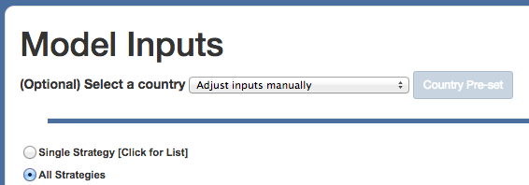

**1. Click here for All Strategies**

The model can return results for All Strategies using Country Pre-set Values or User Input Values. Similar to running the model for a Single Strategy, running FlexDx for All Strategies using User Input Values returns detailed model output results for each of the nine diagnostic strategies as well as summary data. Running FlexDx for All Strategies using Country Pre-set Values will only return summary data.

**Tabs for results returned**

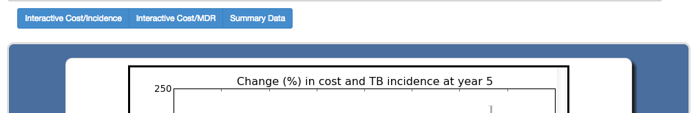

If the user does not have the data for the User Inputs available, the user can first select their country of interest to load the Country Pre-set Values for the model parameters. The user will then click to select All Strategies and then click “Run Model with User Input Values“ to return detailed results for All Strategies.

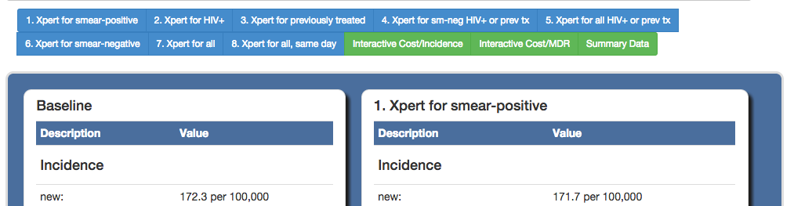

**Tabs for additional results returned**

# Part III: FlexDx TB Model Results

## 

The FlexDx TB Model generates five-year projections of the epidemiological impact and cost-effectiveness of nine diagnostic strategies in reducing TB transmission and mortality. The results that are returned will differ depending on diagnostic strategy selection and whether the model is run with pre-calculated country values versus user input values for the required parameters.

## 

## 3.1 Output when running with Country Selection for Pre-set Values

Since we have pre-calculated the country scenarios, we are able to provide more detail on when running the FlexDx Model with these, including interactive graphs and uncertainty ranges.

The model options reflecting the Epidemiological Scenario and Cost parameter values that were used to generate the results returned are displayed at the top of the page in each of the Incidence, MDR, and Summary results tabs. If the values for any of the parameters are not appropriate for their setting, users can click the ‘Back to Inputs’ button to return to the model inputs page and adjust the values as necessary.

**Click to return to the model inputs page**

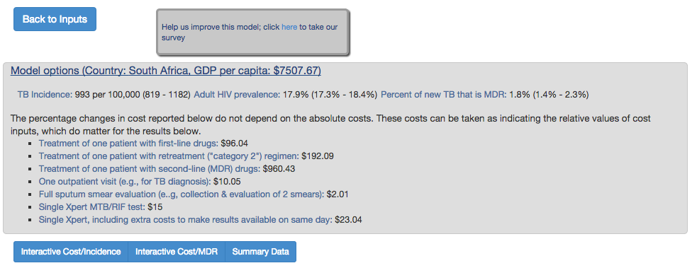

If the pre-calculated country values are markedly different from the parameter values in any individual setting, users are encouraged to compare those values to a pre-calculated country value to get an idea of the level of uncertainty in estimates, plus how the changes in input parameters change the outputs.

### 3.1.1 Interactive Incidence/Cost Tab

The model projections using the Country Pre-set values are based on relative rather than absolute changes in costs and outcomes.

**Click to view Tab**

**Click to select one of the Alternative Scenarios**

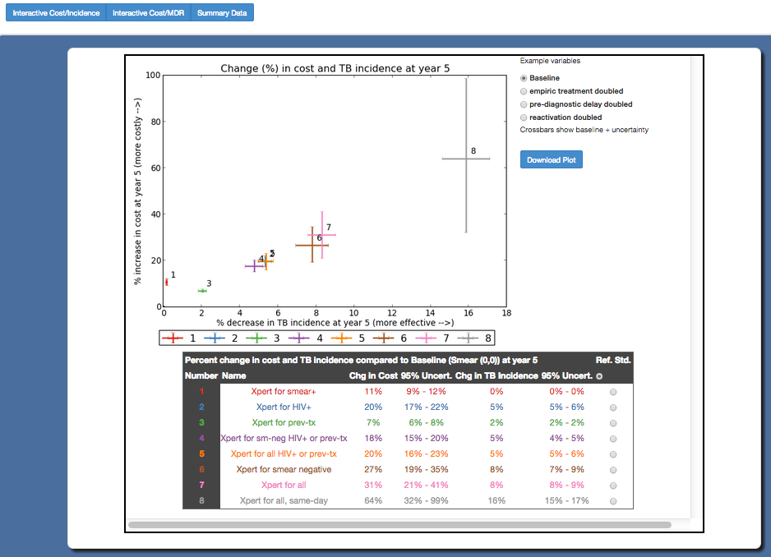

**Click to download plot**

**Click to change the reference standard**

**Cross bars**

* **Percent change in cost and TB incidence at year 5 for all strategies compared to Baseline Graph and Table**

This graph displays the percent ***increase*** in cost for implementing the diagnostic strategy at year 5 [cost] vs. the percent ***decrease*** in TB incidence at year 5 [effectiveness] for all strategies compared to baseline (smear). The table below the graph reports the same data in numerical form.

* **Estimate cross bars**

The cross bars in the graph represent 95% uncertainty ranges for the model’s projected percent change estimate for TB incidence (vertical bar) and cost (horizontal bar). 95% uncertainty ranges result from varying the values of all parameters in the model simultaneously by +/- 10% of their original value (and thus may underestimate true uncertainty, if those values truly vary by more than 10%).

* **Alternative Scenarios selection options**

The Alternative Scenarios are designed to show the effect on model outputs of key inputs. Users may select from the following alternative scenarios which will cause dots to appear on the graph that demonstrate the potential impact of doubling one of these parameters.

Importantly, these three variables have strong influence on the model’s results and likely vary by more than +/-10% from one setting to the next. These parameters are key to the model’s impact estimates, and the effect of varying these parameters is not fully captured within the uncertainty ranges provided. Thus, the 95% uncertainty cross bars for the range of diagnostic strategy outputs represent the range that might be expected if inputs are varied to a certain pre-specified extent (here, +/-10% of the underlying value). *They are not 95% confidence intervals in the statistical sense.*

If users think that empiric treatment, pre-diagnostic delay, and reactivation as a cause of active TB are high in their setting, then the model likely overestimates the impact of better diagnostic testing in that setting. These options allow users to see the impact of doubling each of these input variables to help give an idea of how great this overestimation is likely to be.

**Alternative Scenario Options:**

* **Baseline:** No change to input values
* **Empiric treatment doubled:** Double the probability of empiric treatment in someone who tests negative for active TB (but actually has TB) from 25% to 50%.
* **Pre-diagnostic delay doubled:** Double the period of infectiousness before seeking care from 9 months to 18 months
* **Reactivation doubles:** Double the rate of reactivation, which likewise increases the probability that a case of active TB is due to reactivation vs. recent infection

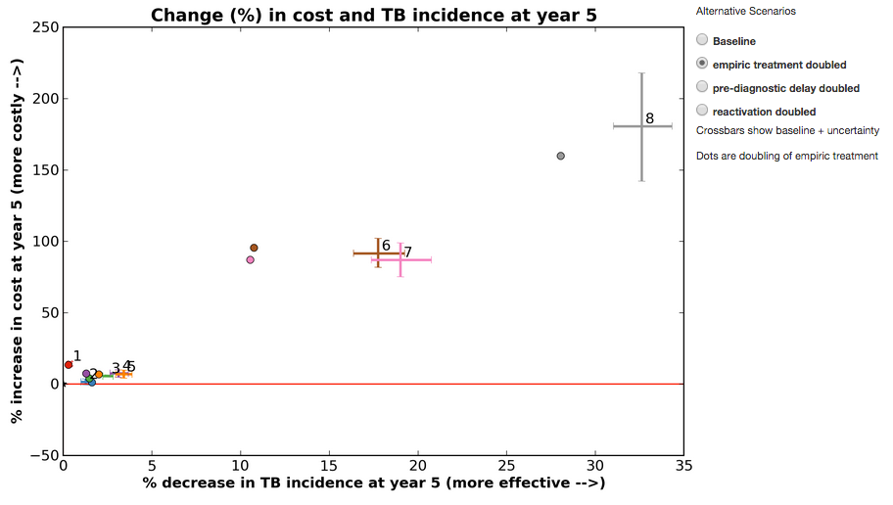

**Dots representing doubling of selected scenario**

**Output with an Alternative Scenario selected**

* **Reference Standard**

The default reference standard is sputum smear microscopy. To change the reference standard for comparison in the Percent change in TB incidence and cost Table, the user can select the radio buttons on the right side of the table corresponding to the diagnostic test option that you wish to use as the reference.

Changing the reference standard will cause the number and cross bars corresponding the selected reference strategy to turn black in the graph above. The Cost and Incidence estimates in the table will change to reflect the selected reference standard.

### 3.1.2 Interactive MDR/Cost Tab

As with incidence, the model projections using the Country Pre-set values are based on relative rather than absolute changes in costs and outcomes.

**Click to view Tab**

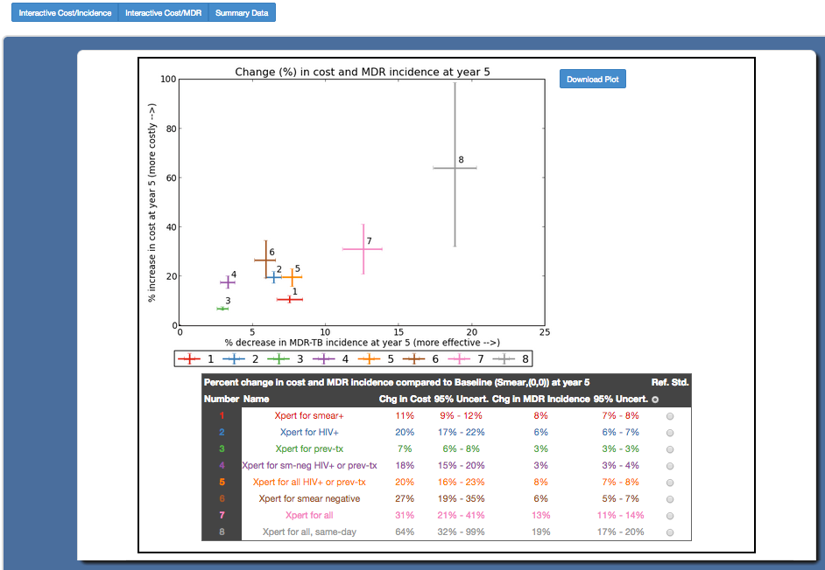

**Click to change the reference standard**

**Click to download plot**

**Cross bars**

* **Percent change in cost and MDR incidence at year 5 for all strategies compared to Baseline Graph and Table**

This graph displays the percent ***increase*** in cost for implementing the diagnostic strategy at year 5 [cost] vs. the percent ***decrease*** in MDR-TB incidence at year 5 [effectiveness for MDR] for all strategies compared to baseline (smear). The table below the graph likewise gives these estimates in numerical form.

* **Estimate cross bars**

The cross bars in the graph represent 95% uncertainty ranges for the model’s projected percent change estimate for MDR-TB incidence (vertical bar) and cost (horizontal bar). 95% uncertainty ranges result from varying the values of all parameters in the model simultaneously by +/- 10% of their original value.

* **Reference Standard**

The default reference standard is sputum smear microscopy. To change the reference standard for comparison in the Percent change in MDR-TB and cost Table, you can select the radio buttons on the right side of the table corresponding to the diagnostic test option that you wish to use as the reference.

Changing the reference standard will cause the number and cross bars corresponding the selected reference strategy to turn black in the graph above. The Cost and Incidence estimates in the table will change to reflect the selected reference standard.

### 3.1.3 Summary Data Tab

The Summary Data Tab provides the user with a summary of the FlexDx TB Model results for TB and MDR Incidence, Mortality, Year 1, and Year 5 projections.

**Click to view Tab**

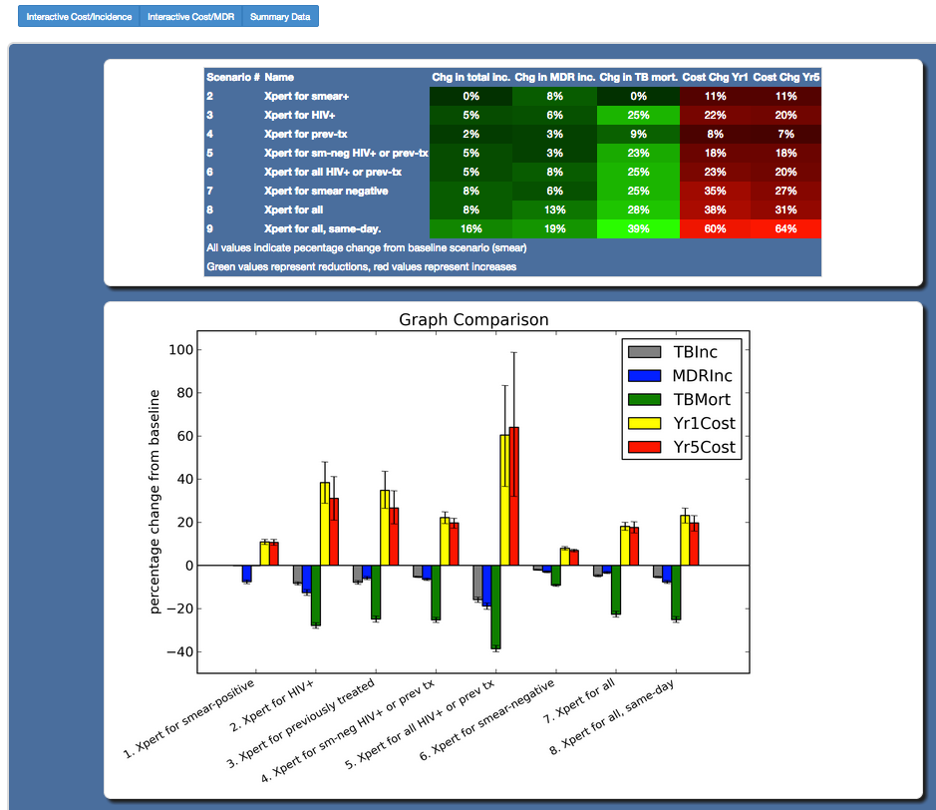

* **Comparison of Diagnostic Strategy Impacts Bargraph**

This graph shows the impact of the diagnostic strategies on percentage change in annual TB incidence, MDR-TB incidence, TB mortality after 5 years, and implementation costs. The graph displays the projected percent change as it increases or decreases for TB Incidence, MDR Incidence, TB Mortality, Year 1 Costs, and Year 5 Costs comparing each of the diagnostic strategies to Baseline (smear).

* **Comparison of Diagnostic Strategy Impacts Table**

This table displays the projected changes in TB Incidence, MDR Incidence, TB Mortality, Year 1 Costs, and Year 5 Costs as a percent *decrease* (***green***) or *increase* (***red***) for All Strategies compared to the Baseline (smear) diagnostic scenario.

## 3.2 Output when running with User Input Values for a Single Strategy

Users can choose to run the FlexDx TB Model using User Input Values to assess the impact of any single diagnostic strategy in their setting.

The model options reflecting the Epidemiological Scenario and Cost parameter values that were input by the user to generate the FlexDx Model results are displayed at the top of the results page. If the values for any of the parameters are incorrect, users can click the ‘Back to Inputs’ button to return to the model inputs page and adjust the values as necessary.

**Click to return to the model inputs page**

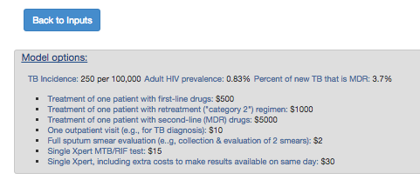

The results page below is an example of the output that will be returned when a user runs the model using User Input Values to assess the impact of any single diagnostic strategy.

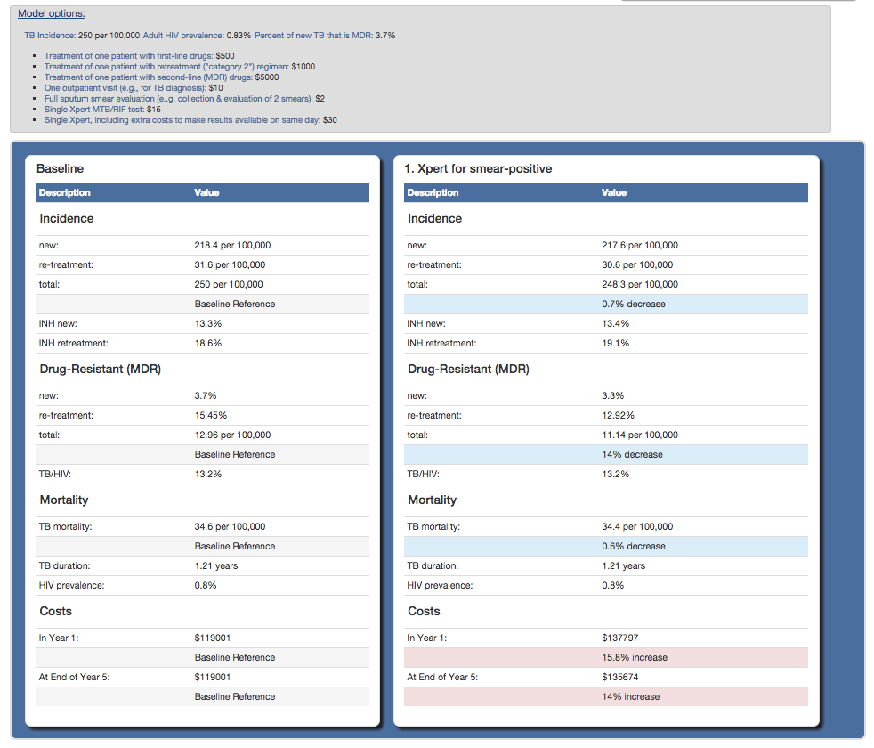

The setting-specific model projections are returned for the Baseline (smear) strategy and for the diagnostic strategy selected by the user. The estimates displayed reflect projections that are expected in Year 5 of the strategy’s implementation.

**Description of the projections:**

* **Incidence**
* **New:** Number of new TB cases per 100,000 population
* **Retreatment:** Number of previously treated TB cases per 100,000 population
* **Total:** Number of all (new + retreatment) TB cases per 100,000 population
* **INH new:** Percent of newly diagnosedTB cases with INH mono-resistance
* **INH retreatment:** Percent of previously treated TB cases with INH mono-resistance
* **Drug-resistance (MDR)**
  + **New:** Percent of newly diagnosedTB cases with multi-drug resistance
  + **Retreatment:** Percent of previously treated TB cases with multi-drug resistance
  + **Total:** Number of MDR TB cases per 100,000 population
* **Mortality**
  + **TB mortality:** Number of deaths from TB per 100,000 population
* **Other Indicators**
  + **TB/HIV:** Percent of all newly diagnosed TB cases that are infected with HIV
  + **TB duration: years**, Average duration of TB disease from the time of becoming infectious to the time of starting successful treatment for a given patient with TB
  + **HIV prevalence:** Percent of the total (adult) population that is currently infected with HIV
* **Costs**
  + **In Year 1:** Cost of the selected strategy, including costs for TB diagnosis and treatment to the healthcare system (not including patient costs), at the end of Year 1 of implementation in U.S. dollars ($)
  + **In Year 5:** Cost of the selected strategy, including costs for TB diagnosis and treatment to the healthcare system (not including patient costs), in Year 5 of implementation in U.S. dollars ($)

## 3.3 Output when running with User Input Values for All Strategies

Users can choose to run the FlexDx TB Model using User Input Values to assess the independent impact of all nine diagnostic strategies in their setting.

Selecting this option will return similar outputs as for the Country Selection for Pre-set Values, but without the uncertainty ranges or additional scenarios with empiric treatment, pre-diagnostic delay, or reactivation doubled. It will also return output similar to running the model for a Single Strategy, but for all strategies compared to Baseline (smear).

The model options reflecting the Epidemiological Scenario and Cost parameter values that were input by the user are displayed at the top of the results pages. If the values for any of the parameters are incorrect, users can click the ‘Back to Inputs’ button to return to the model inputs page and adjust the values as necessary.

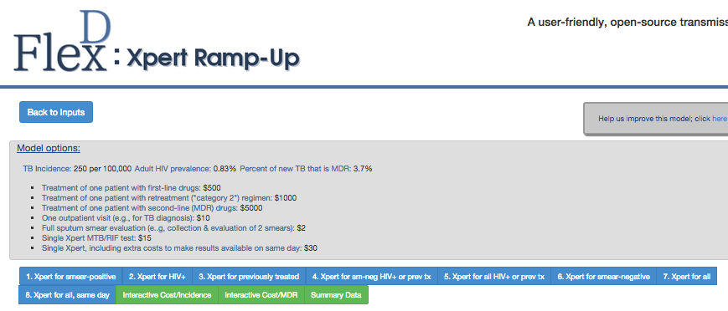

**Click to return to the model inputs page**

### 3.3.1 Nine Single Strategy Tabs

The results page below is an example of the output that will be returned when a user runs the model using User Input Values to assess the impact of All Strategies.

**Click to view Tab**

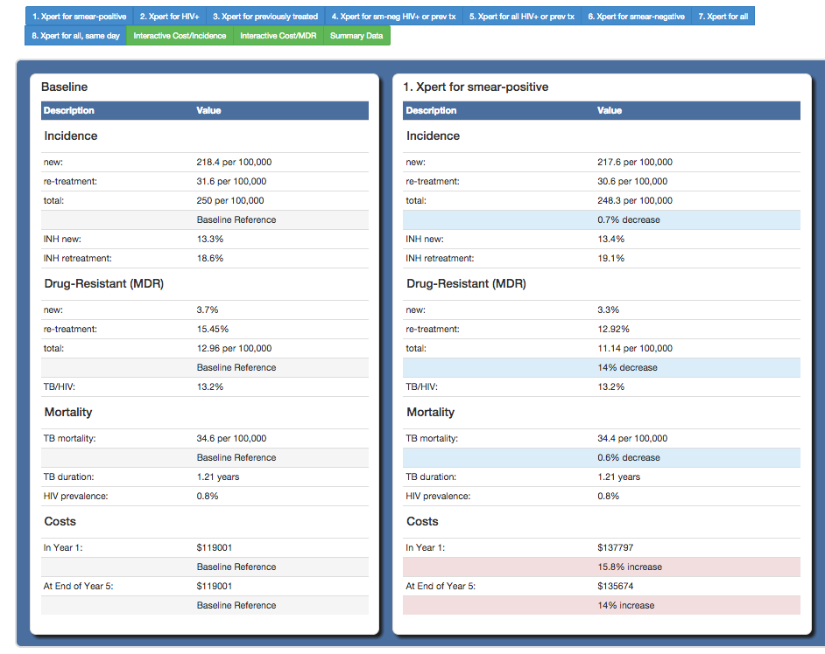

The setting-specific model projections are returned comparing Baseline (smear) strategy to each of the eight diagnostic testing strategies. The estimates displayed reflect projections that are expected by the end of Year 5 of each strategy’s implementation.

Theoutput includes the following model projections for TB Incidence, Multi-drug Resistant (MDR) TB Incidence, Mortality, Other Indicators, and Costs as returned for a single strategy, but for each of the 9 diagnostic strategies. See section 3.2 for a detailed description of the projected estimates.

### 3.3.2 Interactive Incidence/Cost Tab

The FlexDx TB Model will generate an interactive TB Incidence graph and summary table that allows the user to change the reference standard. However, unlike the results for the Country for Pre-set Values, the estimates do not have uncertainty ranges (as generation of these ranges takes thousands of simulations and unfortunately cannot be done in real time).

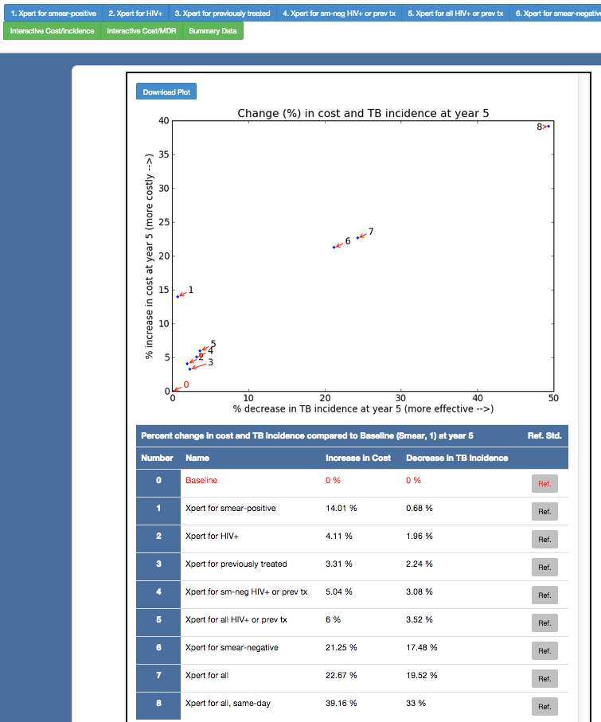

**Click to download plot**

**Reference Standard**

**Click to change the reference standard**

**Click to view Tab**

* **Percent change in cost and TB incidence at year 5 for all strategies compared to Baseline Graph and Table**

This graph displays the percent ***increase*** in cost for implementing the diagnostic strategy at year 5 [cost] vs. the percent ***decrease*** in TB incidence at year 5 [effectiveness] for all strategies compared to baseline (smear). The table below the graph reports the same data in numerical form.

* **Reference Standard**

The default reference standard is sputum smear microscopy. To change the reference standard for comparison in the Percent change in TB incidence and cost Table, the user can select the radio buttons on the right side of the table corresponding to the diagnostic test option that you wish to use as the reference.

Changing the reference standard will cause the number corresponding the selected diagnostic testing strategy to turn red in the graph above. The Cost and Incidence estimates in the table will change to reflect the selected reference standard.

### 3.3.3 Interactive MDR/Cost Tab

The FlexDx TB Model will generate an interactive MDR TB Incidence graph and summary table that allows the user to change the reference standard. However, unlike the results for the Country for Pre-set Values, the estimates do not have uncertainty ranges.

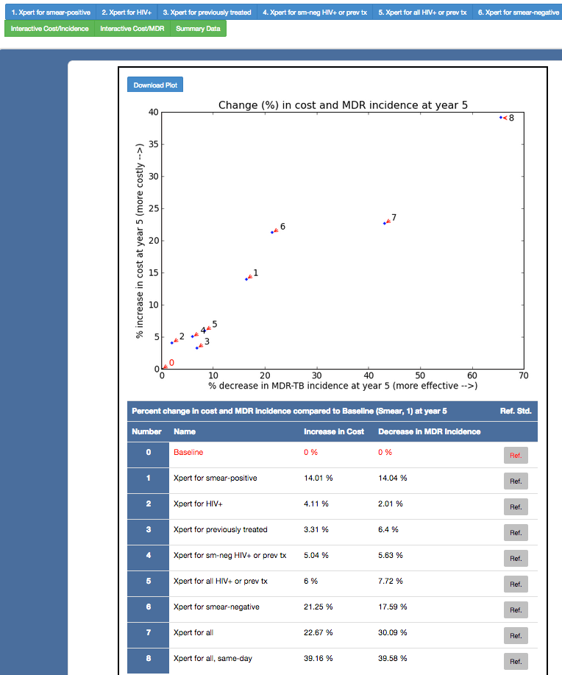

**Click to change the reference standard**

**Reference Standard**

**Click to download plot**

**Click to view Tab**

* **Percent change in cost and MDR incidence at year 5 for all strategies compared to Baseline Graph and Table**

This graph displays the percent ***increase*** in cost for implementing the diagnostic strategy at year 5 [cost] vs. the percent ***decrease*** in MDR-TB incidence at year 5 [effectiveness for MDR] for all strategies compared to baseline (smear). The table below the graph gives these estimates in numerical form.

* **Reference Standard**

The default reference standard is sputum smear microscopy. To change the reference standard for comparison in the Percent change in MDR-TB and cost Table, you can select the radio buttons on the right side of the table corresponding to the diagnostic test option that you wish to use as the reference.

Changing the reference standard will cause the number corresponding the selected diagnostic testing strategy to turn red in the graph above. The Cost and Incidence estimates in the table will change to reflect the selected reference standard.

### 3.3.3 Summary Data

The Summary Data Tab provides the user with a summary of the FlexDx TB Model results for TB and MDR Incidence, Mortality, Year 1, and Year 5 projections.

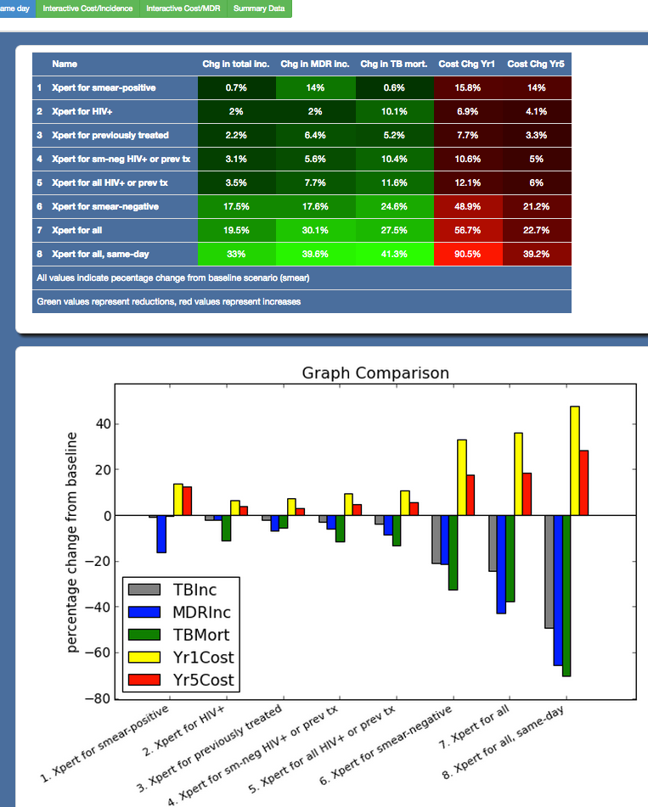

**Click to view Tab**

* **Comparison of Diagnostic Strategy Impacts Bargraph**

This graph shows the impact of the diagnostic strategies on percentage change in annual TB incidence, MDR-TB incidence, TB mortality after 5 years, and implementation costs. The graph displays the projected percent change as it increases or decreases for TB Incidence, MDR Incidence, TB Mortality, Year 1 Costs, and Year 5 Costs comparing each of the diagnostic strategies to Baseline (smear).

* **Comparison of Diagnostic Strategy Impacts Table**

This table displays the projected changes in TB Incidence, MDR Incidence, TB Mortality, Year 1 Costs, and Year 5 Costs as a percent *decrease* (***green***) or *increase* (***red***) for All Strategies compared to the Baseline (smear) diagnostic scenario.

## 3.4 Changing the reference group

The default reference standard is sputum smear microscopy for the FlexDx TB Model.

To change the reference standard for comparison in the Percent change in Incidence and cost Tables, the user can select the radio buttons on the right side of the table corresponding to the diagnostic test option that they wish to use as the reference.

See sections 3.1.1, 3.1.2, 3.3.1 and 3.3.2 for more information and instructions.

## 3.5 Extracting results and data

The data output from the FlexDx TB Model can be extracted in several ways.

The Percent change in cost and incidence at year 5 for all strategies compared to Baseline Graphs can be downloaded from the Interactive Incidence/Cost and Interactive MDR/Cost Tabs by clicking on the ‘Download Plot’ button in the graph windows. The buttons are highlighted in sections 3.1.1, 3.1.2, 3.3.1 and 3.3.2.

The numerical data contained in the output for running the model for a Single Strategy, Percent change in cost and incidence at year 5 for all strategies compared to Baseline Tables, and that in the Summary Table must be extracted manually from this version of the FlexDx TB Model, though we plan for future versions to allow users to download files in Excel format.

## 3.6 Model validation

Using data from published global estimates of TB indicators, we validated the projections of the model for Southeast Asia, a high TB incidence setting, with a TB incidence 250 cases per 100,000 population per year. Below we compare the estimates from the FlexDx TB Model to the 2012 WHO global estimates for Southeast Asia:

* TB mortality of all incident TB: 14% compared to 14% by WHO
* HIV-associated TB of all incident TB: 13% versus 13% by WHO
* Previously-treated cases of all incident cases: 13% compared to 14% by WHO
* Duration of TB disease: 1.2 years versus 1.4 years by WHO
* MDR-TB prevalence in previously treated cases: 15.4% versus 20% by WHO*

(*Unlike our model, country notifications often count failure and recurrence after default in the same person as two separate cases.)

Additional information on validating the FlexDx TB Model can be found in our manuscript by Dowdy et al. published in eLife Sciences 2014.

# Part IV: Using FlexDx Results: Case Studies

Choosing a diagnostic testing strategy to implement in the context of a local or national TB program can be challenging, as the ideal solution is highly dependent on local conditions in which the test is to be implemented. However, the FlexDx TB Model is the first freely available web-based tool that allows users without modeling expertise to customize and run a transmission model that is specific to their local setting. By using the FlexDx TB Model to produce estimates to help evaluate the potential impact of multiple diagnostic strategies, local TB program decision-makers can make implementation choices informed by setting-specific data.

## 4.1 Case study from India with Country Pre-set Values

The following case study is written in the form of a concept note for a proposal for funding to aid in scale-up. We will use India to illustrate a country-level case study where the FlexDx TB Model could be used to help inform decisions to scale-up the Xpert MTB/RIF assay for TB diagnostic testing. We will run the model using the Country Pre-set Values for India to produce epidemiologic population projections.

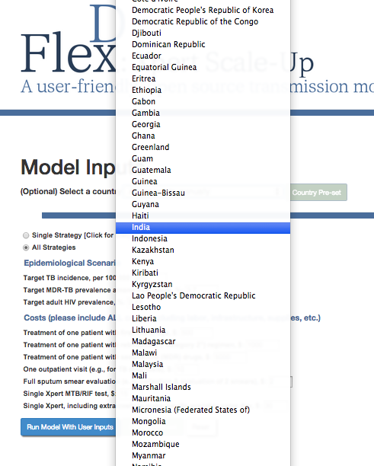 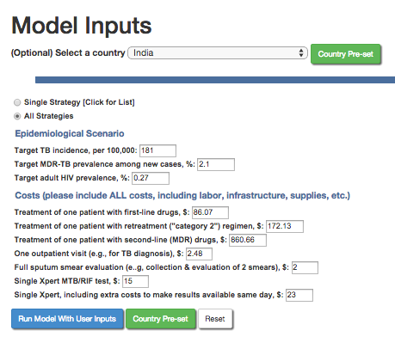

**Click to run FlexDx TB Model using WHO Pre-set Values for India**

**Select India (country of interest) from the list of countries**

**Example Concept Note for TB in India**

**Country Disease Context**

In India today, it is estimated that two deaths occur every three minutes from tuberculosis (TB).1 Although TB is a curable disease, it remains a major global health problem throughout the world as the second leading infectious disease cause of death worldwide after human immunodeficiency virus (HIV).2 In 2012, there were 8.6 million incident TB cases and 1.3 million TB deaths according to the World Health Organization (WHO). With an estimated 2.2 million incident TB cases (176 per 100,000) in 2012, India’s TB case burden accounts for 26% of the world’s incident cases.1–3 WHO ranks India as the top country for TB burden with its total population over 1.2 billion people, 2.8 million prevalent TB cases (230 per 100,000), and 270,000 TB-related deaths (22 per 100,000).4 Additionally, 2.2% of all new cases and 15% of all retreatment cases in India were diagnosed with multidrug-resistant TB (MDR-TB) in 2012.4 India also ranks as the top country accounting for 31% of the global total (2.9 million) of missed TB cases that were either not diagnosed or diagnosed but not reported the national TB program.2

The Government of India’s Revised National Tuberculosis Control Programme (RNTCP) began implementation of the WHO’s global TB control strategy of directly observed therapy short-course (DOTS) in 1998 and expanded to countrywide coverage by 2006.1 The RNTCP currently provides decentralized access to free diagnostic and treatment services for patients with TB in approximately 13,000 sputum smear microscopy centers and 650,000 DOTS centers within the public health care system.1 Although this access to public government health care is widely available, prolonged delays from symptom onset to treatment initiation still occur and are associated with seeking additional medical counsel or second opinions, female gender, site of TB disease, and absence of local diagnostic services.5–7

Early diagnosis and effective treatment of TB are critical to mitigate the burden of TB transmission; however, the most widely used TB diagnostic test globally, sputum smear microscopy for acid-fast bacilli, is over 125 years old and routinely fails to detect half of all TB cases.8 In India, there is evidence that TB diagnostic and treatment practices among private healthcare providers and laboratories are not consistent with national or international guidelines.9 For example, serologic antibody tests for TB are commonly used in the Indian private sector, and inappropriate TB prescriptions are common.10,11

**National Strategic Plan (NSP)**

Based on a negative policy recommendation from the WHO, the Indian government in 2012 banned the manufacture, sale and distribution of the sero-diagnostic test kits for diagnosis of tuberculosis.2 As a result, the diagnostic landscape in India is changing with the availability of novel automated TB diagnostic technologies, such as the Xpert MTB/RIF assay (Xpert) and the line probe assay. Owing to its high sensitivity to detect TB and rifampicin resistance in two hours, Xpert is recommended by WHO for diagnosis of individuals at risk of having MDR-TB or HIV-associated TB and as a follow-on test to microscopy.2 Unfortunately, other serological tests (e.g., QuantiFERON Gold In-Tube), designed for diagnosis of latent TB infection, are also increasingly being used for active TB diagnosis in India.12 A recent initiative called the Initiative for Promoting Affordable Quality TB tests (IPAQT) has made WHO endorsed tests more affordable in the private sector, with an effort to address the gap left by the ban on serological tests.2 Nonetheless, in order for the utility of new diagnostics to be realized, strategies for improving TB diagnostic practices in India need to be evidence-based and informed by data in the context of diagnostic scenarios where they will be used.13,14

To address these issues underlying the TB epidemic in India, the RNTCP aims to develop and implement the following initiatives and research priorities from the 2014 annual report15:

* + Nationwide laboratory scale-up to strengthen culture and DST capabilities
  + National TB drug-resistance survey
  + Increased TB/HIV collaborative activities via the National TB/HIV Coordination Committee
  + Implementation of Isoniazid Preventative Therapy (IPT)
  + Prioritization of Xpert MTB/RIF to all presumptive TB cases among people living with HIV for early diagnosis of TB and drug resistance
  + Improved HIV testing of patients with TB and presumptive TB through provider initiated testing and counseling (PITC)
  + Improved access to diagnostic and treatment services for TB
  + Improved programmatic management of drug resistance (MDT) through increased universal access to free quality anti-TB drugs across India
  + Implementation of Nikshay case based online software for TB surveillance reporting and recording

**Implementation of the NSP**

India has committed $100 million to scale-up of Xpert within the country and is currently the second leading procurer of the diagnostic technology with 32 testing sites.2 In 2014, the RNCTP completed a feasibility study on introducing Xpert across 18 Tuberculosis Units in 12 states under programmatic conditions. The RNTCP is currently using Xpert for the diagnosis of TB and MDR TB in high-risk populations such as HIV-infected individuals and pediatric patients.15 Further, the RNCTP initiated the RNTCP TB Xpert Project with support form UNITAID, WHO, and Stop TB Partnership to provide rapid decentralized diagnosis of MDR TB.15 Laboratory sites are also implementing a mechanism to adopt public-private mix models to provide diagnosis of TB and MRD TB in the private sector through this initiative.15

**Funding request justification**

The objective of this funding request is to scale-up the national TB response, specifically to expand coverage and improve access to TB diagnostic testing and treatment services by improving laboratory capacity for rapid diagnosis of TB using the Xpert MTB/RIF assay. By improving and increasing TB diagnosis in India’s health sectors, the RNTCP aims to increase the number of patients receiving timely and effective treatment, thus ultimately reducing the burden of TB transmission and disease in India. However, the overall impact of implementing new diagnostic tools countrywide is still unknown. It is unclear whether the impact of India’s investment in Xpert can be maximized by deployment in the public sector or by providing private providers with access to the test. It is also unclear if tests like Xpert will have much impact if they are not implemented as point-of-care testing (POCT) programs whereby results are used for rapid, same-day treatment initiation.

To explore the potential impact of implementation of Xpert under different conditions within the existing healthcare infrastructure, the FlexDx TB Model16,17 was used to estimate the projected impact of nine different diagnostic strategies for implementation and scale-up of Xpert. The strategies include: 0) sputum smear microscopy for all patients (baseline); sputum smear for all patients plus: 1) Xpert for smear-positive patients, 2) Xpert for HIV-infected individuals, 3) only Xpert for previously treated patients, 4) Xpert for smear negative HIV-infected patients or previously treated patients, 5) Xpert for all HIV-infected patients (regardless of smear status) or previously treated patients, 6) Xpert only for smear negative, 7) Xpert for all patients with symptoms, and 8) Xpert for all patients with TB symptoms with the ability to provide same-day results to patients in the same clinical encounter.

The following parameter estimates based on WHO country estimates for India were used in the FlexDx TB Model to assess the impact of the nine diagnostic strategies for scale-up of Xpert:

Target TB incidence, per 100,000: 181

Target MDR-TB prevalence among new cases, %: 2.1

Target adult HIV prevalence, %: 0.27

Treatment of one patient with first-line drugs, $: 86.07

Treatment of one patient with retreatment ("category 2") regimen, $: 172.13

Treatment of one patient with second-line (MDR) drugs, $: 860.66

One outpatient visit (e.g., for TB diagnosis), $: 2.48

Full sputum smear evaluation (e..g, collection & evaluation of 2 smears), $: 2

Single Xpert MTB/RIF test, $: 15

Single Xpert, including extra costs to make results available same day, $: 23

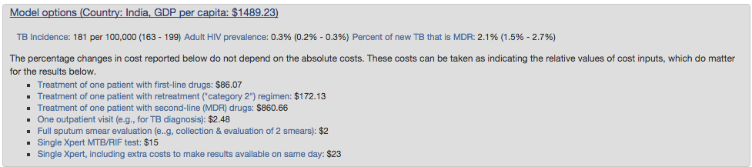

In this high TB incidence setting, the FlexDx TB Model calculates the projected incremental 5-year cost and impact comparing the nine diagnostic strategies to aid in the decision making process. The projected results from the FlexDx TB Model for implementation of the nine strategies to scale-up Xpert in India are summarized in the table and graphs below.

|  |  |  |  |  |  |
| --- | --- | --- | --- | --- | --- |
|  | Model Estimated Projections*,16 | | | | |
| Diagnostic Strategies | Change in TB Incidence (95% Uncertainty Range) | Change in MDR Incidence (95% Uncertainty Range) | Change in TB Mortality | Change in Cost for Year 1 | Change in Cost for Year 5 |
| 0. Baseline (smear) | ref | ref | ref | ref | ref |
| 1. Xpert for smear+ | -0% (0-0%) | -12% (11-13%) | -0% | +15% | +14% |
| 2. Xpert for HIV+ | -1% (1-2%) | -1% (1-2%) | -5% | +2% | +2% |
| 3. Xpert for previously treated | -3% (2-3%) | -6% (6-6%) | -4% | +7% | +6% |
| 4. Xpert for sm-neg HIV+ or prev tx | -3% (3-4%) | -5% (5-6%) | -7% | +9% | +7% |
| 5. Xpert for all HIV+ or prev tx | -3% (3-4%) | -7% (7-8%) | -8% | +8% | +7% |
| 6. Xpert for smear- | -18% (16-19%) | -17% (16-18%) | -23% | +101% | +92% |
| 7. Xpert for all | -19% (17-21%) | -27% (25-28%) | -25% | +96% | +87% |
| 8. Xpert for all, same day | -33% (31-34%) | -38% (37-41%) | -39% | +183% | +181% |

***\*Note to users: values were extracted from the FlexDx TB Model output and entered into the table above for reporting purposes.***

16 The model estimated projections were generated using the FlexDx TB Model Pre-set Values for India.

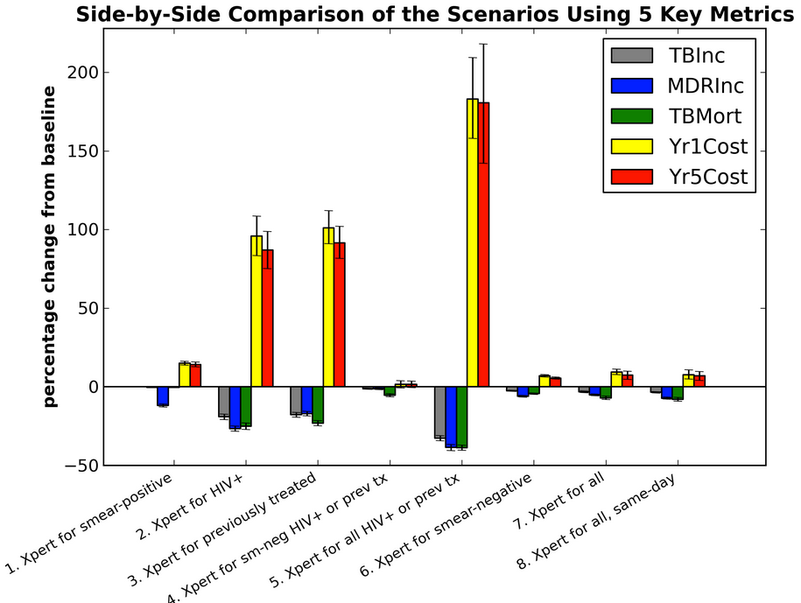

**for scale-up in India**

Given the current conditions of the nationwide TB epidemic in India and using smear microscopy as the baseline for comparison, the FlexDx TB Model projects that the current RNCTP strategy of targeting high risk populations (i.e., (2) Xpert for patients infected with HIV) will produce small reductions in TB incidence (estimated change: -1%, 95% uncertainty range: 1-2%) and a slight decrease in TB mortality (estimated change: -5%) with little increase in cost over the next five years (estimated change: +2%). This targeted strategy may prove effective in settings of high HIV prevalence; however, alternative strategies may produce a greater impact if additional funding is available to implement a broader diagnostic approach. The other HIV-targeted strategies, namely (4) Xpert for smear-negative HIV-infected or previously treated patients, and (5) Xpert for all HIV-infected or previously treated patients, may achieve a greater reductions in TB (estimated change: -3% and -3%, respectively), MDR TB incidence (estimated change: -5% and -7%, respectively), and mortality (estimated change: -7% and -8%), but with greater increases in costs both initially in the first year of implementation and over time in to the fifth year of implementation. Thus, these gains in TB diagnostics targeting HIV-infected patients will require some additional funding to scale-up Xpert as currently proposed by the RNTCP.

By comparison, given that India is a low HIV prevalence setting, the FlexDx TB Model projections suggest that implementing Xpert using broader diagnostic strategies may result in greater impact on the TB epidemic. While (7) Xpert for all patients with presumptive TB requires a substantial financial investment for initial implementation (estimated change in cost year 1: +96%), it is quite effective for reducing TB and MDR TB incidence (estimated change: -19% and -27%, respectively), and TB mortality (estimated change: -25%). Further, the costs for this strategy will decrease over a five year implementation period (estimated change in cost year 5: +87%). A secondary advantage of investing in the Xpert for all strategy is that its implementation will help prepare India for subsequent scale-up of (8) Xpert for all same-day diagnosis, which is projected to achieve even greater reductions in TB and MDR TB incidence, and mortality. While these projected estimates of impact require a significant increase in funding to achieve the estimated reductions, these strategies for the implementation and scale-up of Xpert in India have the greatest promise to make a true impact on India’s TB epidemic. Regardless, these gains will not be achieved if funding remains at its current level.

The potential impact of scaling-up Xpert using these diagnostic strategies is further illustrated using the alternative scenarios offered in the FlexDx TB Model and depicted in the graphs below. By doubling the rate of empiric TB treatment occurring in India in the model, the effects of most of the strategies remain relatively the same in terms of cost based on the FlexDx projections, though these conditions may result in a decrease in cost for the (8) Xpert for all same-day strategy making it even more appealing. However, increased empiric treatment does decrease the impact of each diagnostic strategy on TB incidence. In particular, the (6) Xpert for smear-negative strategy and the broader strategies of (7) Xpert for all and (8) Xpert for all same-day are most affected by doubling empiric treatment resulting in the greatest reductions in the projected decrease in TB incidence under baseline conditions. These results suggest that in addition to implementing new diagnostics, we must also collect data on patterns of empiric treatment in the public and private sector in India, in order to better refine our estimates of impact for the next round of funding.

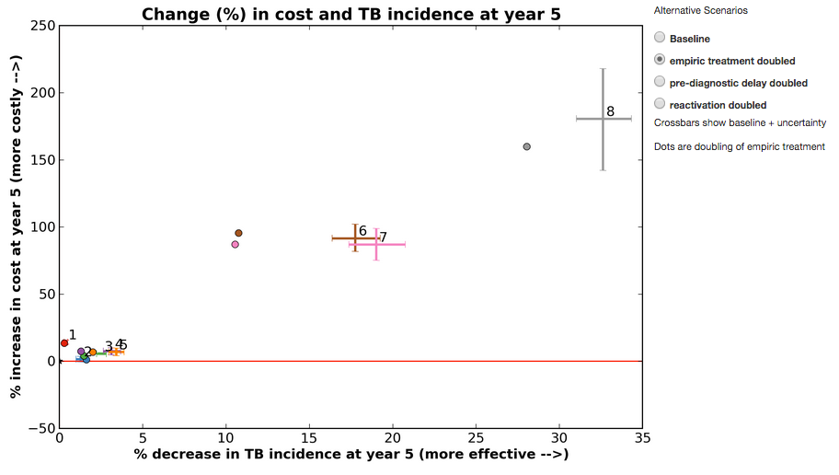

0= Baseline (smear)

1= Xpert for smear-pos

2= Xpert for HIV+

3= Xpert for previously treated

4= Xpert for sm-neg HIV+ or prev tx

5= Xpert for all HIV+ or prev tx

6= Xpert for smear-negative

7= Xpert for all

8= Xpert for all, same day

**if empiric treatment is doubled in India**

Similarly, if the duration of pre-diagnostic delay occurring in India is doubled in the FlexDx TB Model, the relative effect of each strategy remains but the impact on TB incidence is reduced. With greater pre-diagnostic delay, the risk of TB transmission in the community increases as patients spend a greater duration of time with undiagnosed active TB thus allowing for more transmission opportunities prior to diagnosis. Under these circumstances, which are realistic concerns in the context of the TB epidemic in India, the (6) Xpert for smear-negative strategy and the broader strategies of implementing (7) Xpert for all patients with presumptive TB and (8) Xpert for all same-day diagnosis still deliver the greatest impact on the TB epidemic in India, but with an increase in cost compared to implementation under baseline conditions.

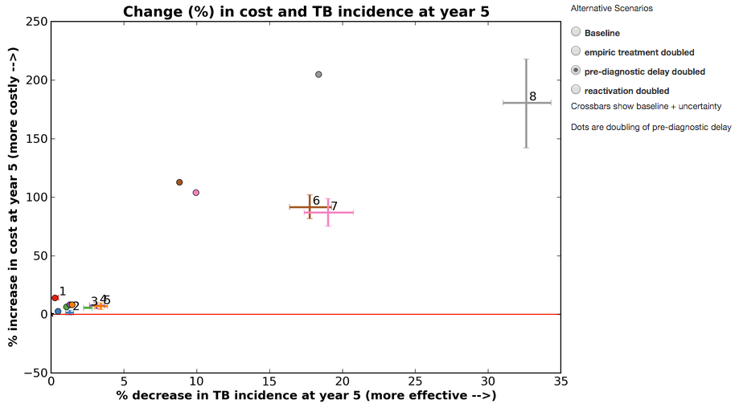

**if pre-diagnostic delay is doubled in India**

0= Baseline (smear)

1= Xpert for smear-pos

2= Xpert for HIV+

3= Xpert for previously treated

4= Xpert for sm-neg HIV+ or prev tx

5= Xpert for all HIV+ or prev tx

6= Xpert for smear-negative

7= Xpert for all

8= Xpert for all, same day

With the evidence provided by the FlexDx TB Model, the priority request is to achieve universal coverage for access to TB diagnostic services using decentralized Xpert for all patients with presumptive TB. This priority is in line with the RNTCP’s overriding objective to reach the unreached and to achieve zero TB deaths. Even when considering key drivers of the TB epidemic in India, Xpert for all patients with presumptive TB stands out as having potential to change the course of the TB epidemic. The prioritization of this strategy is enhanced by its potential to lead the way for subsequent scale-up of same-day diagnosis using Xpert, which is projected to achieve even greater reductions in TB and MDR TB incidence, and mortality.

## 4.1 Case study from Cape Town, South Africa with User Input Values

The following case study is written in the form of a concept note for a proposal for funding to aid in scale-up of Xpert in a local setting.

We will use an urban primary-care health center in Cape Town, South Africa to illustrate a case study in a local setting where the FlexDx TB Model could be used to help inform decisions to scale-up the Xpert MTB/RIF assay for TB diagnostic testing. When using FlexDx in a local context, users may not have estimates available for the input parameters required to run the model. Nonetheless, this case study will illustrate one way that FlexDx can be applied to produce epidemiologic projections for a local setting. To populate the local estimates of TB incidence, MDR-TB, HIV, and costs for this setting, we will use a combination of estimates from the literature and Country Pre-set Values.

We will use the Country Pre-set Values to estimate the cost parameters for the health center in Cape Town. First, we will select South Africa as our country of interest from the list of countries to load its Country Pre-set Values. This will provide us with estimates for the cost parameters and load them in to the Cost input fields.

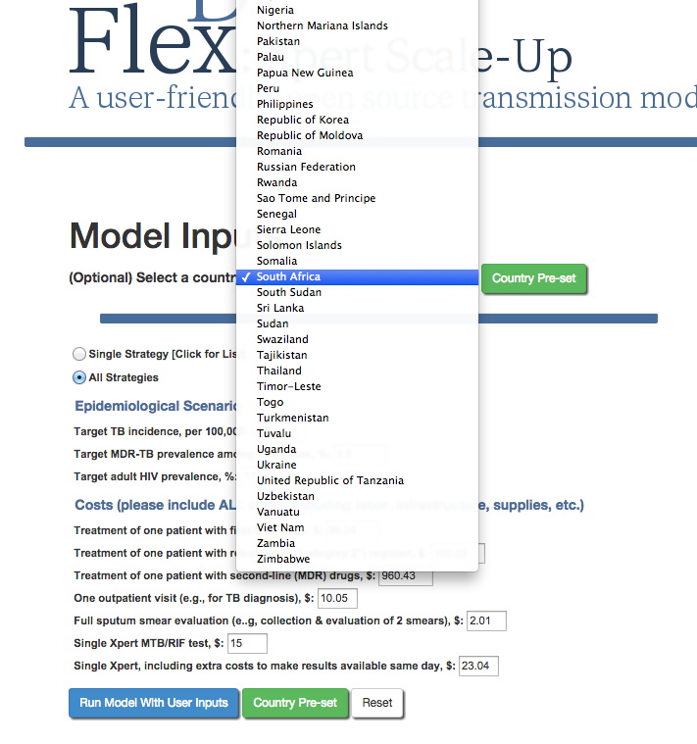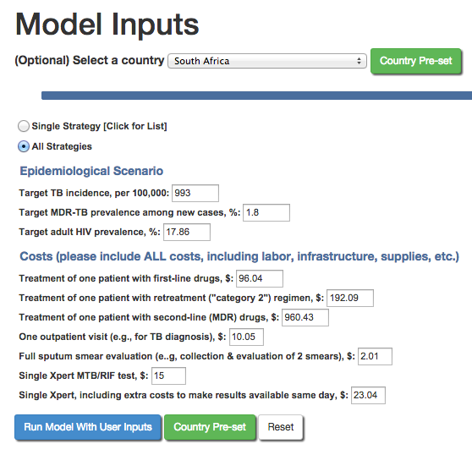

**Model parameters**

**are populated with**

**pre-set values for**

**South Africa**

**Select South Africa from the list of countries**

Next, because we do not have exact estimates of TB incidence, MDR-TB incidence, and HIV prevalence for the Cape Town health center, we will use estimates from a manuscript on Xpert implementation by Boehme et al.18 In this study, there were 2522 adult patients aged 18 years or older with at least 2 weeks of cough who presented to an urban primary-care health center.

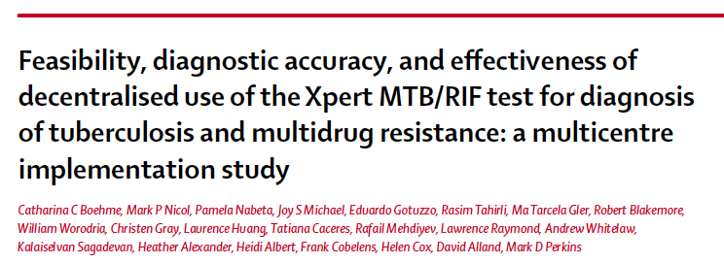

Using the estimates from the manuscript, we will enter the following for epidemiological scenario model inputs:

* Target TB incidence, per 100,000: 1622
* Target MDR-TB prevalence among new cases, %: 3.3
* Target adult HIV prevalence, %: 38

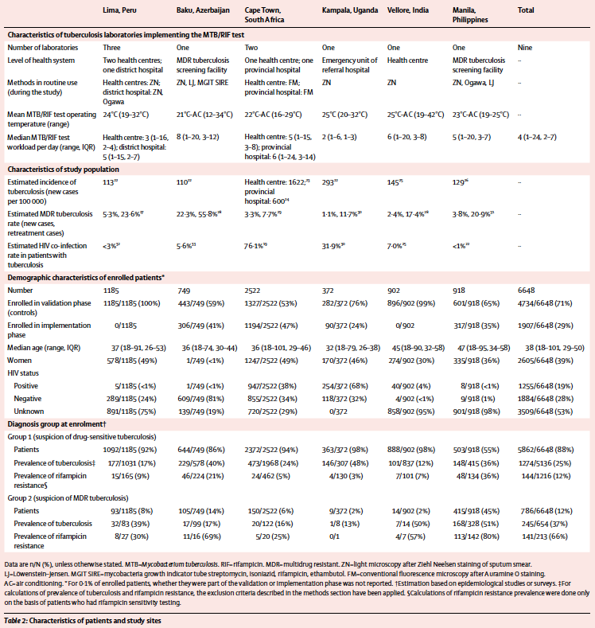

**TB Incidence**

**MDR-TB Prevalence**

**Adult HIV Prevalence**

After entering the setting specific estimates of TB incidence, MDR-TB prevalence, and HIV prevalence in the epidemiological scenario model input fields, we are ready to run the FlexDx TB Model to produce projections for our setting.

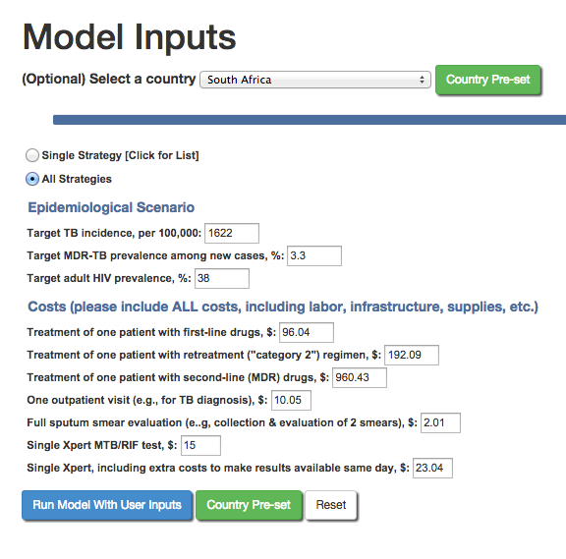

**Run for all strategies**

**After entering all data,**

**click Run Model With User Inputs**

**Model parameters**

**populated with**

**pre-set values for**

**South Africa**

**Model parameters entered for**

**user’s local setting in Cape Town**

The FlexDx TB Model will return projections in an output like this:

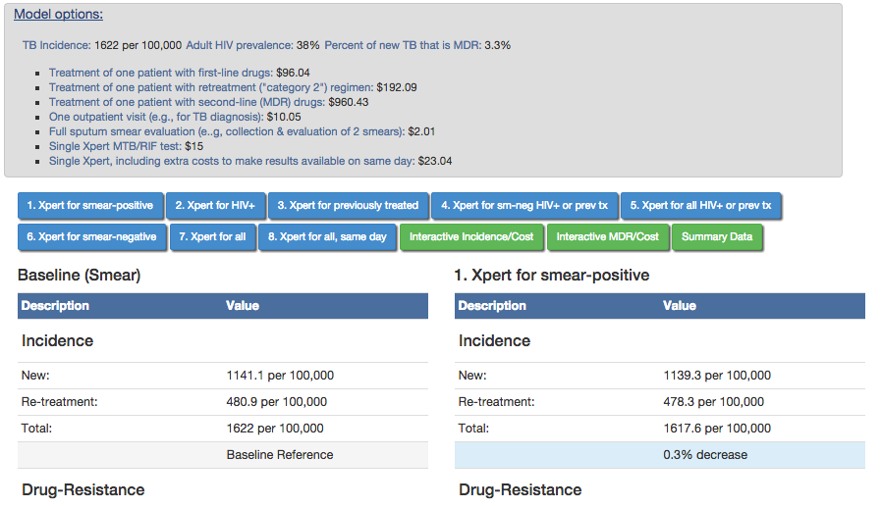

The user can then utilize the estimates calculated by the FlexDx TB Model as data for epidemiological projections for various strategies of scaling-up Xpert as a diagnostic test for TB their setting. In this case study, the estimates project the impact of Xpert scale-up in the urban primary-care health center in Cape Town.

**Example Concept Note for TB in an Urban Primary-Care Health Center in Cape Town, South Africa**

**Country/Setting Disease Context**

Tuberculosis is (TB) remains a major public health problem, especially in South Africa where it is the main cause of morbidity and mortality in people living with HIV/AIDS (PLHIV).2 With 1,003 incident TB cases per 100,000 people, South Africa has the world’s second highest TB incidence rate translating to over half a million newly infected patients in 2012.2 PLHIV account for 65% of patients infected with TB in South Africa, making it the world’s largest population with both TB disease and HIV infection (hereafter referred to as TB/HIV).2 Furthermore, 1.8% of all new cases and 6.7% of all retreatment cases have multidrug-resistant TB adding to the complexity of the problem in South Africa.2 The TB/HIV syndemic in South Africa presents vast challenges to TB control efforts including diagnosis of TB disease.

In the Western Cape Province of South Africa the reported incidence rate of TB continues to be among the highest in the world with 885 incident TB cases per 100,000 in 2010.19 However, estimates of TB incidence in the Cape Town Metro district, which accommodates approximately 66% of the province’s 5.2 million residents, may be even higher with studies reporting incidence rates of 600 to 1,622 cases per 100,000 persons.18 While the prevalence of HIV among antenatal women is reported to be approximately 17.9%, the estimated rate of HIV co-infection in patients with TB is approximately 76.1% in Cape Town.18,20 This staggering rate of TB/HIV makes diagnosis of TB in patients in this setting even more difficult because 24-61% of TB/HIV patients are smear-negative under sputum smear microscopy.21 Thus, the epidemic in South Africa demands better methods for diagnosing TB in the context of this high HIV prevalence setting. The GeneXpert rapid molecular testing system Xpert MTB/RIF (Xpert) assay has improved diagnostic capabilities compared to sputum smear microscopy with 93.9% sensitivity in HIV-infected patients and 72.5% sensitivity in smear-negative culture-positive patients.22

Xpert is currently being implemented nationwide in South Africa; however, despite the great promise the Xpert shows as a diagnostic tool, questions regarding implementation, training, and incorporation in diagnostic testing algorithms remain. These questions become more complex when focusing on the smaller scale of individual health facilities that have setting-specific challenges and differences in the drivers on the TB epidemic.

**National Strategic Plan (NSP)**

The South African National Department of Health began rolling out the GeneXpert rapid molecular testing system Xpert MTB/RIF (Xpert) assay in 2011.23 Xpert is now available in all nine provinces of South Africa and with training and implementation is still ongoing. To continue with the critical efforts in TB control, the South African National and the Western Cape Provincial 2012-2016 Strategic Plans on HIV, STIs, and TB, the following areas were identified as research priorities19,24:

* + Reduce the number of new TB infections as well as the number of TB deaths by 50%
  + Addressing the social and structural drivers of HIV, STI, and TB prevention, care and impact
  + Preventing new HIV, STI, and TB infections
  + Sustaining health and wellness to ensure access to quality treatment, care and support services for those with HIV, STIs, and TB

A key component to each of these priority areas includes mitigating the transmission of TB, which can be achieved through early diagnosis and effective treatment of TB.

**Implementation of the NSP**

Currently, Xpert assays are placed in 207 testing centers across South Africa.23 In the Western Cape Province in 2013, there were 131,349 tests performed using Xpert with 15.4% detecting mycobacterium tuberculosis and 5.0% detecting rifampin resistance.23 However, questions persist as to where Xpert should be implemented, how to best incorporate Xpert testing into the existing diagnostic algorithms, and how to adapt the implementation to address setting-specific challenges.

**Funding request justification**

The objective of this funding request is to scale-up the TB diagnostic testing capacity in Primary-Care Health Center ABC in Cape Town in the Western Cape, South Africa. Specifically, this funding is needed to improve access to TB diagnostic testing and treatment services in this health center by improving laboratory capacity for rapid diagnosis of TB using the Xpert MTB/RIF assay. With a TB incidence rate of 1622 per 100,000, 3.3% prevalence of MDR-TB among new cases, and 76.1% TB/HIV co-infection rate, Primary-Care Health Center ABC is responding to patient needs that represent a greater TB burden than that observed in the country overall. It is critical that we increase the number of patients receiving timely and effective treatment by improving our diagnostic capabilities in order to reduce the burden of TB transmission both within our facility, community, and country. However, it is unclear how best to maximize the impact of implementing Xpert in our facility and whether Xpert will be productive if it not implemented as a point-of-care testing (POCT) program whereby results are used for rapid, same-day treatment initiation.

To explore the potential impact of implementation of Xpert under different conditions within Primary-Care Health Center ABC, the FlexDx TB Model16,17 was used to estimate the projected impact of nine different diagnostic strategies for implementation and scale-up of Xpert. The strategies include: 0) sputum smear microscopy for all patients (baseline); sputum smear for all patients plus: 1) Xpert for smear-positive patients, 2) Xpert for HIV-infected individuals, 3) only Xpert for previously treated patients, 4) Xpert for smear negative HIV-infected patients or previously treated patients, 5) Xpert for all HIV-infected patients (regardless of smear status) or previously treated patients, 6) Xpert only for smear negative, 7) Xpert for all patients with symptoms, and 8) Xpert for all patients with TB symptoms with the ability to provide same-day results to patients in the same clinical encounter.

The following parameter estimates based on WHO country estimates for South Africa and estimates from the literature18 were used in the FlexDx TB Model to assess the impact of the nine diagnostic strategies for scale-up of Xpert:

Target TB incidence, per 100,000: 1622

Target MDR-TB prevalence among new cases, %: 3.3

Target adult HIV prevalence, %: 38

Treatment of one patient with first-line drugs, $: 96.04

Treatment of one patient with retreatment ("category 2") regimen, $: 192.09

Treatment of one patient with second-line (MDR) drugs, $: 960.43

One outpatient visit (e.g., for TB diagnosis), $: 10.05

Full sputum smear evaluation (e..g, collection & evaluation of 2 smears), $: 2.01

Single Xpert MTB/RIF test, $: 15

Single Xpert, including extra costs to make results available same day, $: 23.04



In this high TB, MDR-TB, and HIV burden setting, the FlexDx TB Model calculates the projected incremental 5-year cost and impact comparing the nine diagnostic strategies to aid in the decision making process. The projected results from the FlexDx TB Model for implementation of the nine strategies to scale-up Xpert in Primary-Care Health Center ABC are summarized in the table and graphs below.



***\*Note to users: values were extracted from the FlexDx TB Model output and entered into the table above for reporting purposes.***

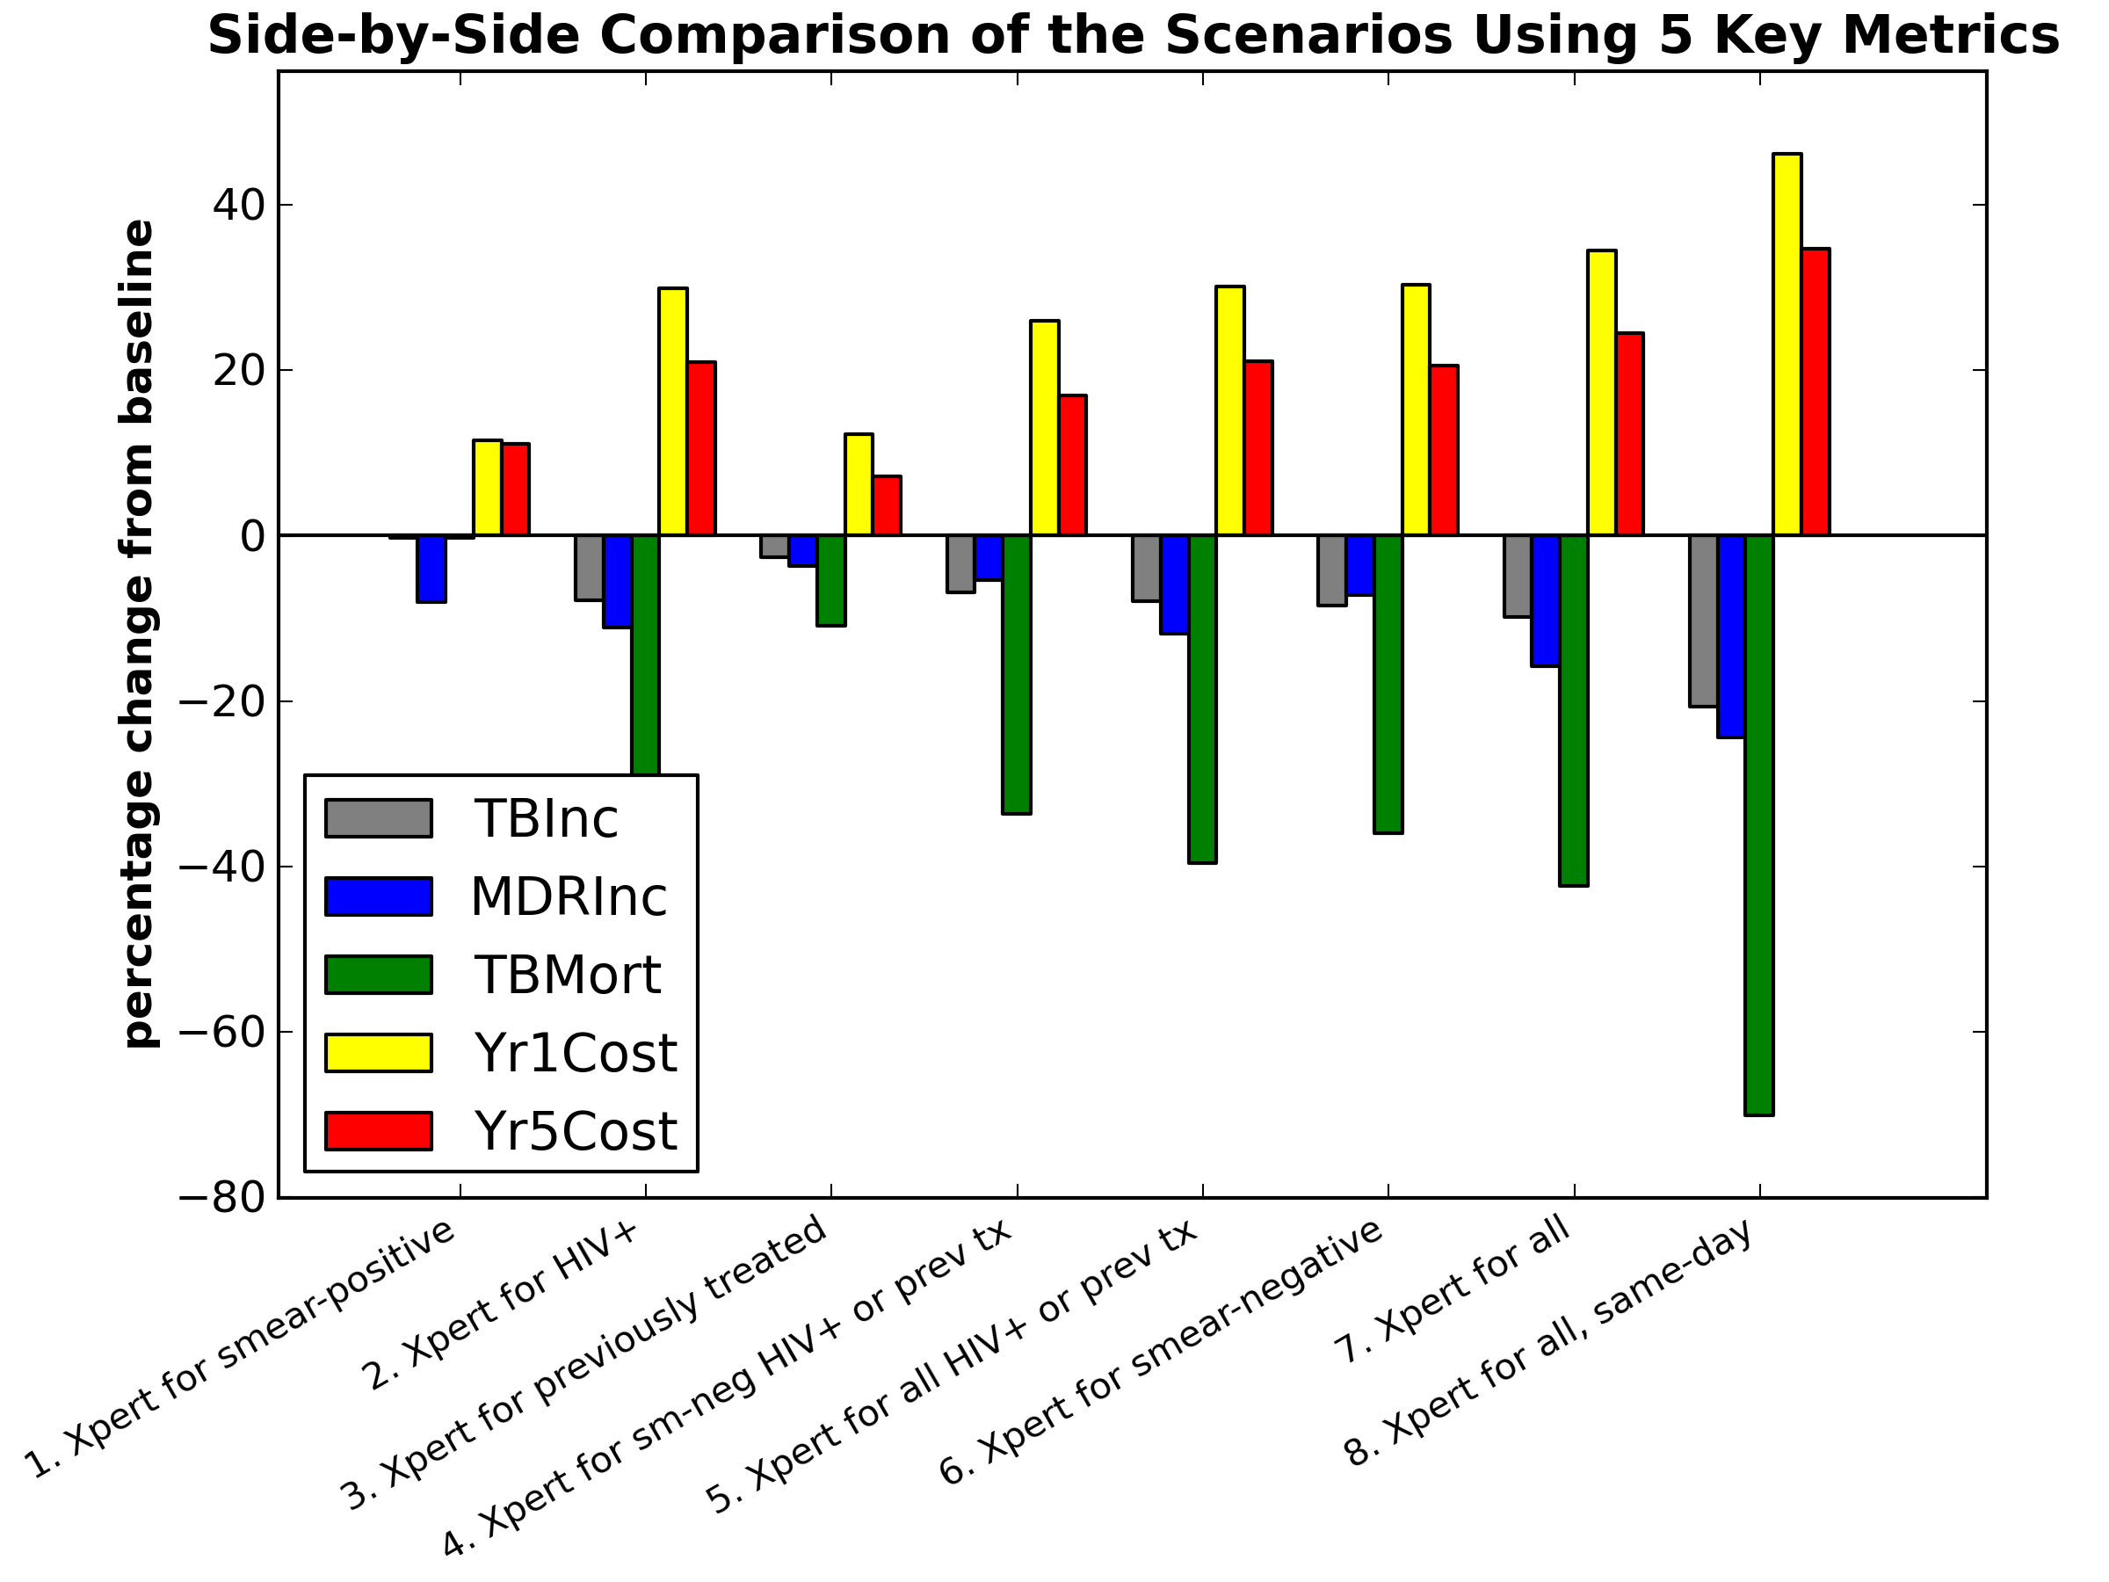

**for scale-up in an urban primary-care health center in Cape Town, South Africa**

Given the epidemiologic estimates of TB burden for Primary-Care Health Center ABC and the current costs of Xpert nationwide TB epidemic and using smear microscopy as the baseline for comparison, the FlexDx TB Model projects that the current South African National TB Program (SA NTP) strategy of using Xpert as the initial screening test for all patients with presumptive TB (i.e., (7) Xpert for all) will have a considerable impact in our setting. The model projects (7) Xpert for all will produce moderate reductions in TB incidence (estimated change: -9%), MDR TB incidence (estimated change: -13.7%), and a large decrease in TB mortality (estimated change: -29.8%) albeit with a 52.6% increase in cost initially in Year 1 that decreases to a 32.3% increase in cost by Year 5 for our Health Center. If we were able to implement (8) Xpert for all same-day diagnosis in our setting, the impact would be even more substantial. The FlexDx TB Model projects that (8) Xpert for all same-day would result in a 17.2% reduction in TB incidence, 19.6% decrease in MDR TB incidence, and a 41.2% decrease in TB mortality at our Health Center. However, the cost to scale-up Xpert for all same-day will require a 85.8% increase in in Year 1 that would decrease to a 53% increase in cost by Year 5 of implementation.

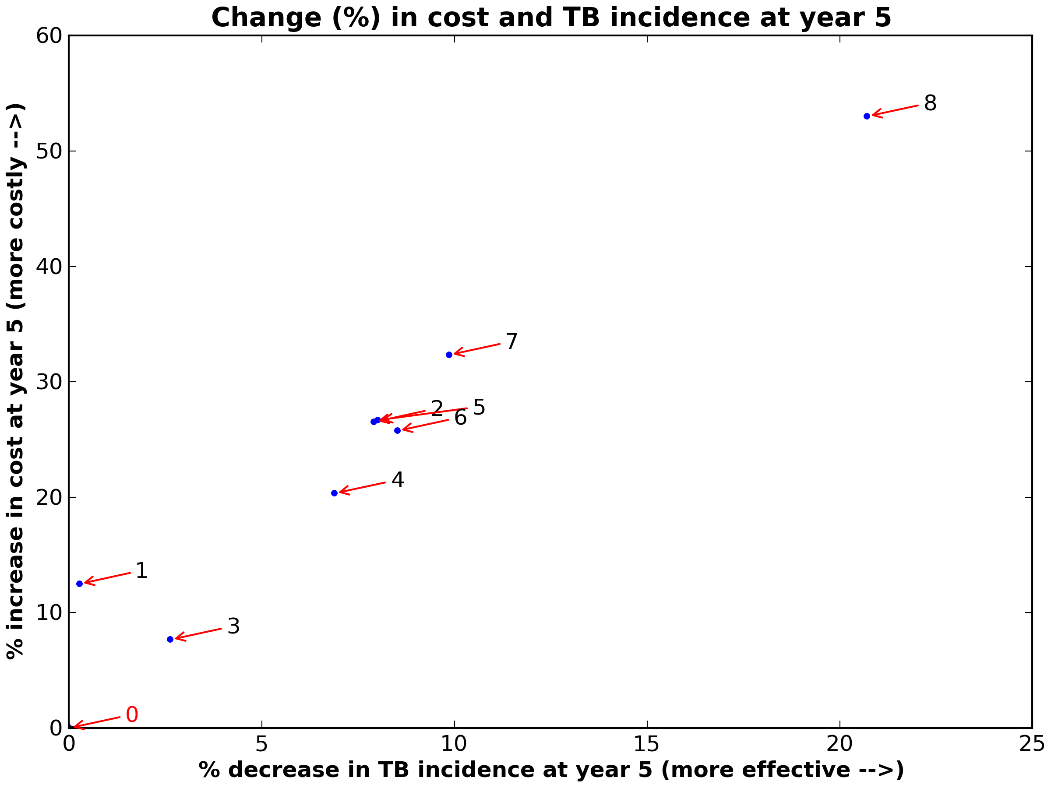

0= Baseline (smear)

1= Xpert for smear-pos

2= Xpert for HIV+

3= Xpert for previously treated

4= Xpert for sm-neg HIV+ or prev tx

5= Xpert for all HIV+ or prev tx

6= Xpert for smear-negative

7= Xpert for all

8= Xpert for all, same day

**for scale-up in an urban primary-care health center in Cape Town, South Africa**

If we implemented Xpert using more targeted strategies, namely (2) Xpert for HIV-infected patients, (4) Xpert for smear-negative HIV-infected or previously treated patients, and (5) Xpert for all HIV-infected or previously treated patients, to address the high HIV prevalence in our setting, the FlexDx TB Model projects decreases in TB incidence of 6.4 to 7.9%, decreases in MDR TB incidence of 5.2 to 10.6%, and decreases in TB mortality of 25.2 to 28.4% with Year 1 cost increases of 35.1 to 43.1% for implementation.

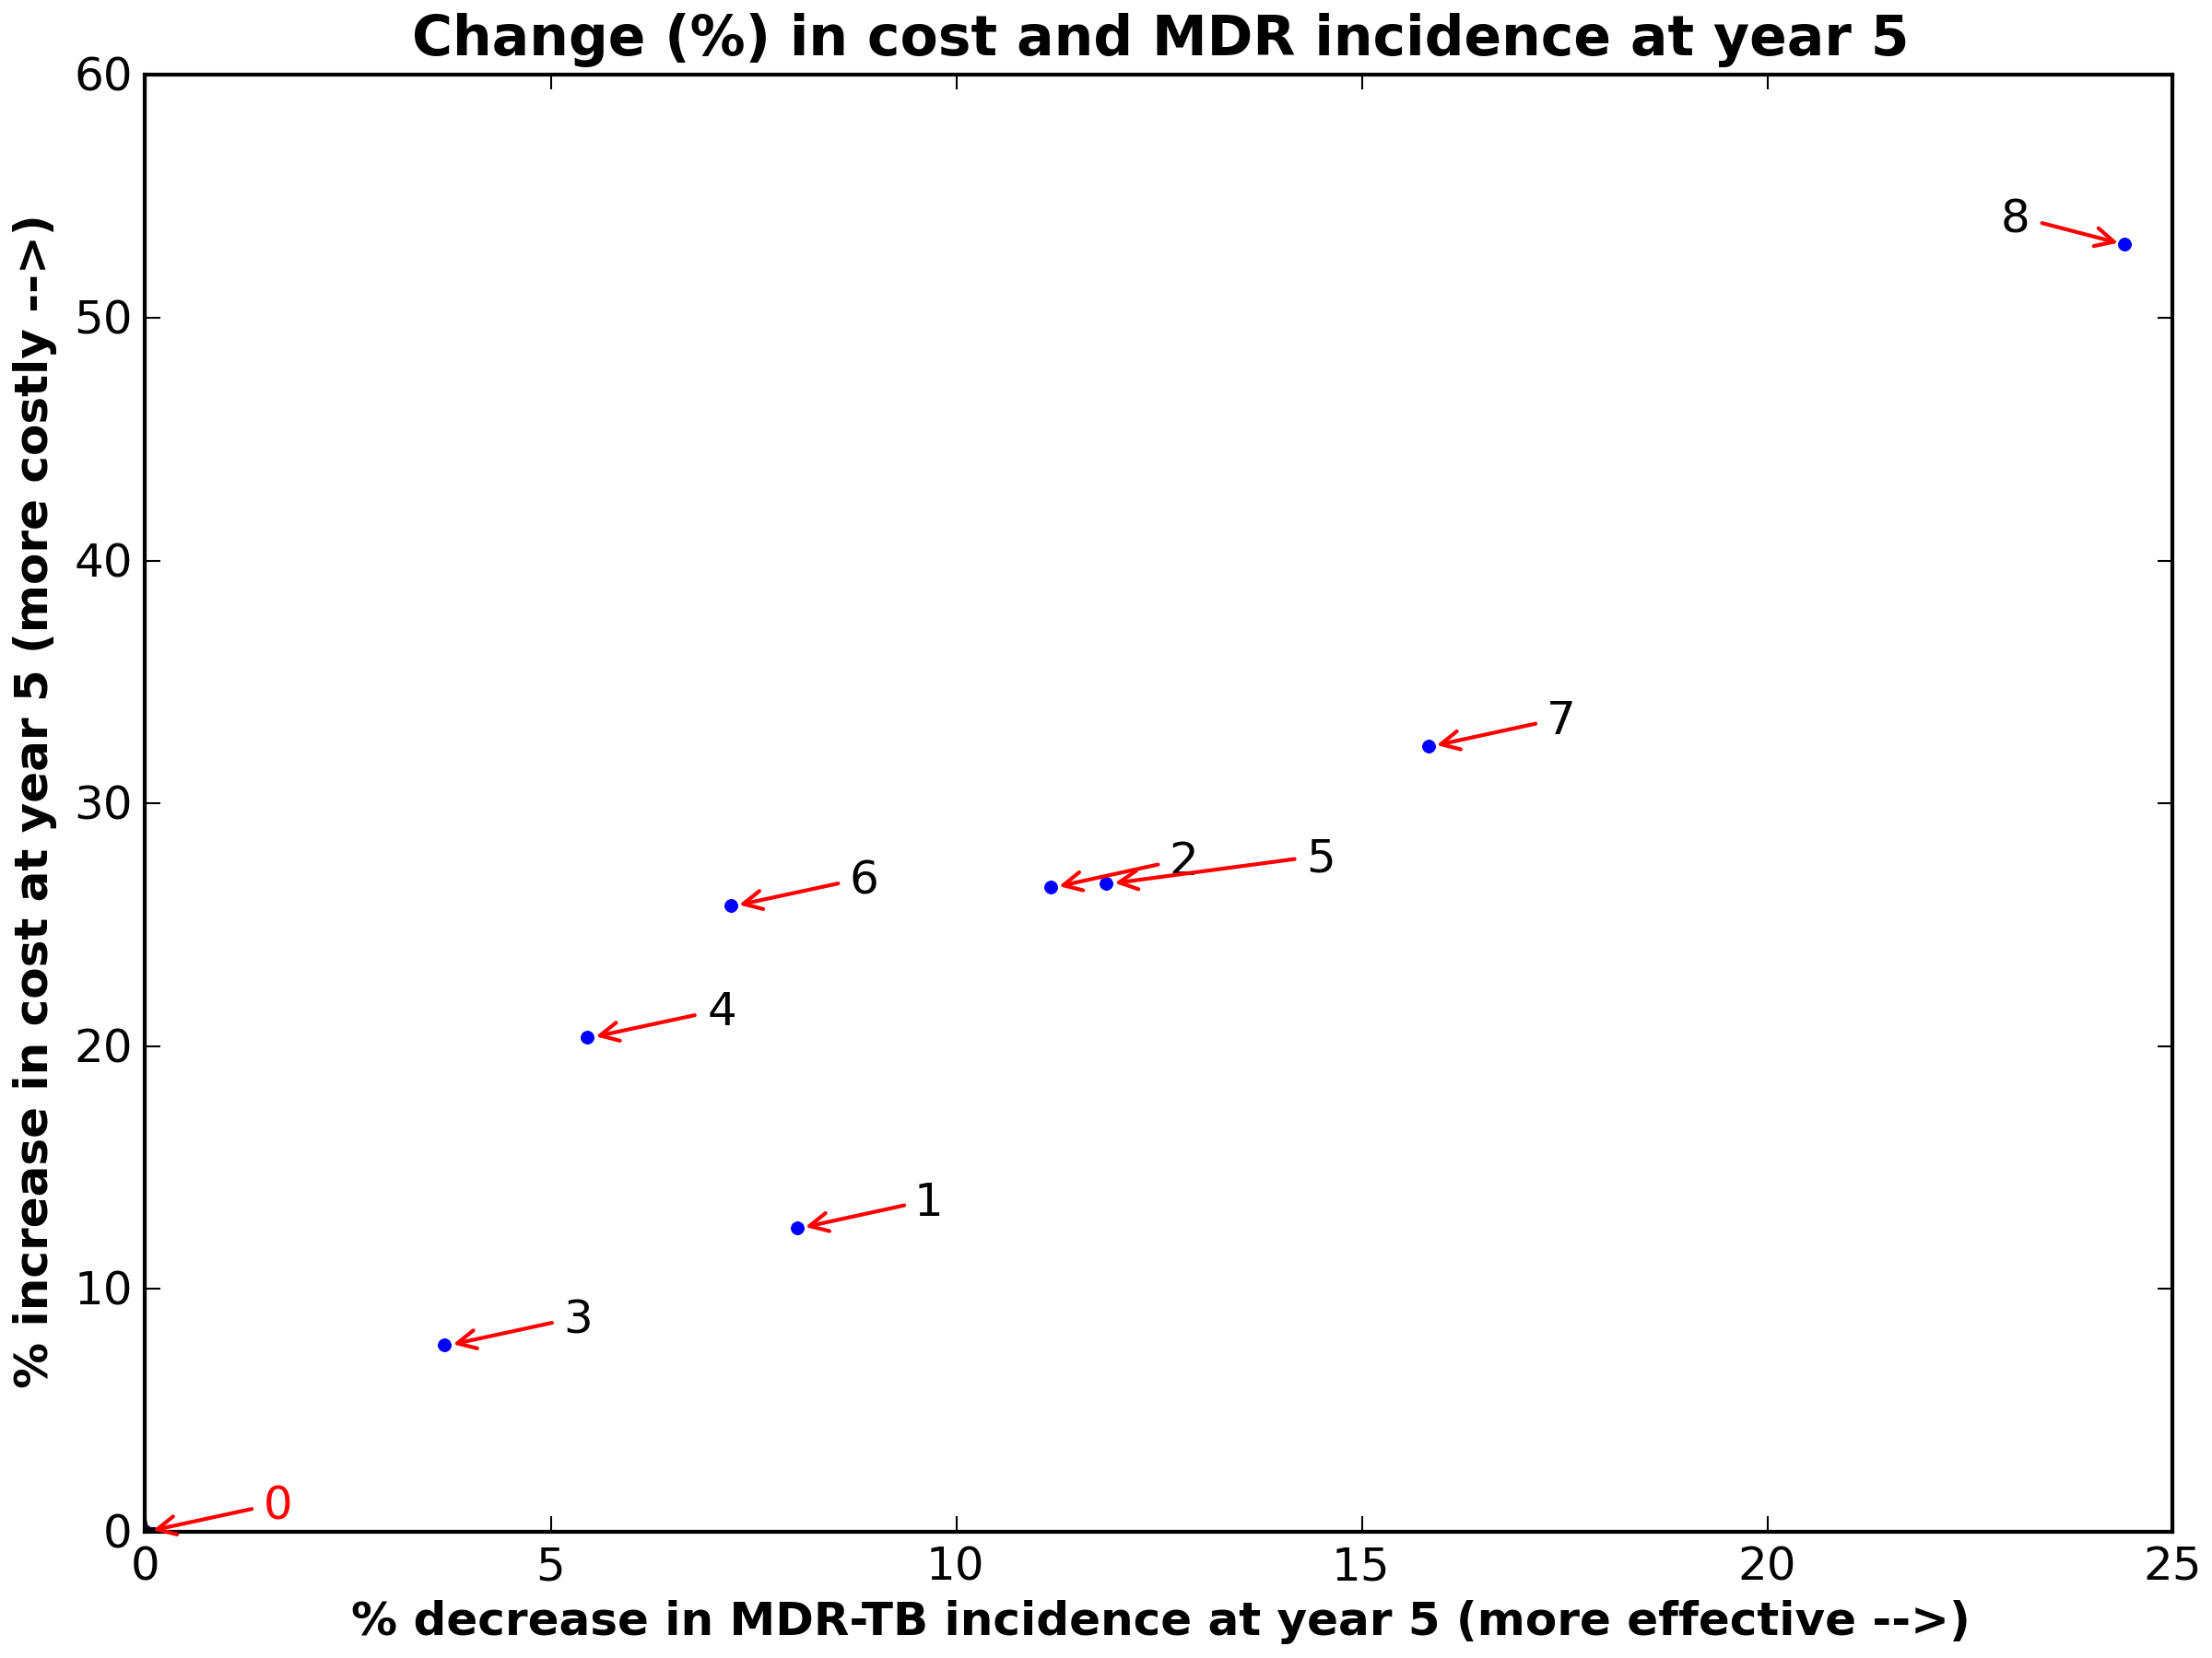

0= Baseline (smear)

1= Xpert for smear-pos

2= Xpert for HIV+

3= Xpert for previously treated

4= Xpert for sm-neg HIV+ or prev tx

5= Xpert for all HIV+ or prev tx

6= Xpert for smear-negative

7= Xpert for all

8= Xpert for all, same day

**for scale-up in an urban primary-care health center in Cape Town, South Africa**

While HIV-targeted strategies may achieve a similar impact on our TB burden for a lower cost, the broader strategies involving Xpert for all are better aligned with the SA NTP strategic plan. The Xpert for all strategies are estimated to produce a greater impact in our severely high burden setting, but they will require a large amount of additional funding for scale-up of Xpert within our Health Center. Additionally, if we are able to implement the (7) Xpert for all strategy initially, our health center will be better positioned for subsequent scale-up of same-day diagnosis using Xpert, which is projected to achieve even greater reductions in TB and MDR TB incidence, and mortality. While these broader Xpert implementation strategies require a significant increase in funding to achieve the estimated reductions, they also have the greatest promise to make a true impact on the TB epidemic unfolding in our health center. Regardless of the selected strategy for Xpert scale-up, these gains in our TB control efforts will not be achieved if funding remains at its current level.

With the evidence provided by the FlexDx TB Model, the priority request is to achieve access to TB diagnostic services using Xpert for all patients with presumptive TB at Primary-Care Health Center ABC. This priority is in line with the SA NTP’s overriding objective to decrease TB deaths by 50%. Given the critical role of HIV and drug-resistance in the TB epidemic in South Africa, Xpert for all patients with presumptive TB stands out as having potential to change the course of the TB epidemic. The prioritization of this strategy is enhanced by its potential to lead the way for subsequent scale-up of same-day diagnosis using Xpert, which is projected to achieve even greater reductions in TB and MDR TB incidence, and mortality.

# Glossary of Terms

**Model.** Computer system designed to demonstrate the probable effect of two or more variables that might be brought to bear on an outcome. Such models can reduce the effort required to manipulate these factors and present the results in an accessible format.

**Module.** Synonym for “model.”

**Parameter.** A value, usually unknown (and which therefore has to be estimated), used to represent a certain population characteristic. Within a population, a parameter is a fixed value that does not vary. Each sample drawn from the population has its own value of any statistic that is used to estimate this parameter.

**Variable.** Synonym for “parameter.”

**Input.** A known or estimated value used to represent a certain population characteristic for a parameter (or variable) that can be entered into a parameter field to be included as an estimate of a required parameter to run the model.

**Epidemiologic population projection.** Computations depicting the future course of a population’s size, its structure, and its interaction with dynamics such as fertility, mortality, and migration. The projection is constructed based on assumptions about the future course of those population dynamics.

**Pop-up menu.** A menu from which users can select items or actions. Pop-up menus can appear anywhere on the screen.

**Pull-down menu.** A menu opened by clicking on key words at the top edge of the screen. Pull-down menus allow users to select operations.

**Radio button.** These buttons emulate raised buttons on early radios, which were punched to select radio stations. The graphically portrayed raised “radio buttons” on interfaces permit users to select among alternatives.

**Diagnostic strategy.** A method for implementing diagnostic tests for active TB in the context of the local TB setting and program.

**Retreatment.** A person that has a history of treatment with anti-TB drugs for a previous episode of TB.

# 

# Acronyms and abbreviations

**FlexDx** Flexible Diagnostics

**TB** Tuberculosis

**MDR** Multidrug-resistant

**Xpert** GeneXpert MTB/RIF assay

**DST** Drug-susceptibility testing

**WHO** World Health Organization

**US** United States

**Chg** Change

**Inc** Increase

**Smear** Sputum Smear Microscopy

**Smr-neg** Smear-negative

**Prev-tx** Previous treatment or retreatment

**INH** Isoniazid

**HIV** Human Immunodeficiency Virus

**Ref. Std.** Reference Standard

**Mort.** Mortality

**Yr** Year

**TBInc** TB Incidence

**MDRINc** MDR TB Incidence

**TBMort** TB Mortality

**Yr1Cost** Year 1 Cost

**Yr5Cost** Year 5 Cost

# References

1. Division CT. Tuberculosis India 2011, Annual report of the Revised National Tuberculosis Control Programme, Ministry of Health and Family Welfare, Government of India [Internet]. 2011. Available from: http://www.tbcindia.nic.in/documents.html

2. World Health Organization. Global tuberculosis report 2013 [Internet]. WHO; 2013 [cited 2013 Dec 9]. Available from: http://apps.who.int/iris/bitstream/10665/91355/1/9789241564656_eng.pdf

3. WHO | Tuberculosis country profiles | India [Internet]. WHO. [cited 2013 Dec 10];Available from: http://www.who.int/tb/country/data/profiles/en/India

4. Organization WH. Global tuberculosis report 2012 [Internet]. 2012. Available from: www.who.int

5. Sreeramareddy CT, Qin ZZ, Satyanarayana S, Subbaraman R, Pai M. Delays in diagnosis and treatment of pulmonary tuberculosis in India: a systematic review. Int J Tuberc Lung Dis Off J Int Union Tuberc Lung Dis 2014;18(3):255–66.

6. Kapoor SK, Raman AV, Sachdeva KS, Satyanarayana S. How did the TB patients reach DOTS services in Delhi? A study of patient treatment seeking behavior. PloS One 2012;7(8):e42458.

7. Charles N, Thomas B, Watson B, Sakthivel MR, Chandrasekeran V, Wares F. Care seeking behavior of chest symptomatics: a community based study done in South India after the implementation of the RNTCP. PloS One 2010;5(9):10.1371/journal.pone.0012379.

8. Small PM. Strengthening laboratory services for today and tomorrow. Plenary Lecture given during the 38th Union World Lung Conference on Lung Health, Cape Town, South Africa, 8-12 November 2007. Int J Tuberc Lung Dis Off J Int Union Tuberc Lung Dis 2008;12(10):1105–9.

9. WHO | WHO warns against the use of inaccurate blood tests for active tuberculosis [Internet]. WHO. [cited 2013 Mar 27];Available from: http://www.who.int/mediacentre/news/releases/2011/tb_20110720/en/

10. Dowdy DW, Steingart KR, Pai M. Serological Testing Versus Other Strategies for Diagnosis of Active Tuberculosis in India: A Cost-Effectiveness Analysis. PLoS Med [Internet] 2011 [cited 2013 Mar 27];8(8):e1001074. Available from: http://dx.doi.org/10.1371/journal.pmed.1001074

11. Udwadia ZF, Pinto LM, Uplekar MW. Tuberculosis Management by Private Practitioners in Mumbai, India: Has Anything Changed in Two Decades? PLoS ONE [Internet] 2010 [cited 2013 Mar 27];5(8):e12023. Available from: http://dx.doi.org/10.1371/journal.pone.0012023

12. Pai M. Tuberculosis Control in India: Time to get dangerously ambitious? Natl Med J India [Internet] 2011;24(2):65–8. Available from: http://www.nmji.in/archives/Volume-24/Issue-2/Editorial-I.pdf

13. Lin H-H, Langley I, Mwenda R, et al. A modelling framework to support the selection and implementation of new tuberculosis diagnostic tools [State of the art series. Operational research. Number 8 in the series]. Int J Tuberc Lung Dis 2011;15(8):996–1004.

14. Cobelens F, Hof S van den, Pai M, Squire SB, Ramsay A, Kimerling ME. Which New Diagnostics for Tuberculosis, and When? J Infect Dis [Internet] 2012 [cited 2013 Oct 3];205(suppl 2):S191–8. Available from: http://jid.oxfordjournals.org/content/205/suppl_2/S191

15. Central TB Division, Directorate General of Health Services. TB India 2014, Revised National TB Control Programme, Annual Status Report [Internet]. New Delhi, India: Central TB Division, Directorate General of Health Services, Ministry of Health and Family Welfare; 2014. Available from: http://www.tbcindia.nic.in/pdfs/TB%20INDIA%202014.pdf

16. FlexDx: Xpert Scale-Up, A user-friendly open source transmission model of TB [Internet]. Baltimore, MD, USA: Johns Hopkins Bloomberg School of Public Health; 2014 [cited 2014 Sep 22]. Available from: https://flexdx2.modeltb.org

17. Dowdy DW, Andrews JR, Dodd PJ, Gilman RH. A user-friendly, open-source tool to project impact and cost of diagnostic tests for tuberculosis. eLife [Internet] 2014 [cited 2014 Sep 22];e02565. Available from: http://elifesciences.org/content/early/2014/06/04/eLife.02565

18. Boehme CC, Nicol MP, Nabeta P, et al. Feasibility, diagnostic accuracy, and effectiveness of decentralised use of the Xpert MTB/RIF test for diagnosis of tuberculosis and multidrug resistance: a multicentre implementation study. Lancet [Internet] 2011;377:1495–505. Available from: http://www.ncbi.nlm.nih.gov/pubmed/21507477

19. Western Cape Government Department of Health. Western Cape Provincial Strategic Plan on HIV/AIDS, STIs and TB, 2012-2016 [Internet]. South Africa: Western Cape Government Department of Health; 2012. Available from: http://www.westerncape.gov.za/assets/departments/health/provincial_strategic_plan_on_hiv_aids_stis_tb_2012_-_2016_-_15_june_2012.pdf

20. Gupta RK, Lawn SD, Bekker L-G, Caldwell J, Kaplan R, Wood R. Impact of HIV and CD4 count on tuberculosis diagnosis: analysis of citywide data from Cape Town, South Africa. Int J Tuberc Lung Dis Off J Int Union Tuberc Lung Dis [Internet] 2013 [cited 2014 Sep 26];17(8):1014–22. Available from: http://www.ncbi.nlm.nih.gov/pmc/articles/PMC3990260/

21. Meyer-Rath G, Schnippel K, Long L, et al. The Impact and Cost of Scaling up GeneXpert MTB/RIF in South Africa. PLoS ONE [Internet] 2012 [cited 2013 Oct 9];7(5):e36966. Available from: http://dx.doi.org/10.1371/journal.pone.0036966

22. Boehme CC, Nabeta P, Hillemann D, et al. Rapid molecular detection of tuberculosis and rifampin resistance. N Engl J Med 2010;363(11):1005–15.

23. National Health Laboratory Service. GeneXpert MTB/RIF Progress Report, July 2014 [Internet]. South Africa: National Health Laboratory Service; 2014. Available from: http://www.nhls.ac.za/assets/files/GeneXpert%20Progress%20Report%20July%202014_Final.pdf

24. South African Ministry of Health, South African National AIDS Council. South African National Strategic Plan on HIV, STIs, and TB, 2012-2016 [Internet]. South Africa: South African Ministry of Health; 2012. Available from: http://www.sanac.org.za/nsp/the-national-strategic-plan